Motion Re: Endorsement of the Flying of the Hiawatha Belt Flag on National Aboriginal Day

Whereas, McGill is located on the traditional territory of the Kanien'kehá:ka (Mohawk Nation), one of the six member nations of the Haudenosaunee Confederacy,

Whereas, the Hiawatha Belt symbolizes the five original nations of the Haudenosaunee Confederacy united by the Great Law of Peace (see Appendix 1), and has been adopted as the flag of the Haudenosaunee Confederacy,

Whereas, the Principal’s Task on Diversity, Excellence and Community Engagement recommends that McGill “commit to developing and sustaining long-term relationships with local Aboriginal communities,”

Whereas, National Aboriginal Day seeks to “celebrate the unique heritage, diverse cultures and outstanding achievements of First Nations, Inuit and Métis peoples in Canada,”

Whereas, the Aboriginal Affairs Working Group has submitted a request to McGill’s Secretary-General Stephen Strople for the Hiawatha Belt flag to be flown on McGill campus on the next National Aboriginal Day (June 21, 2014),

Resolved, that the AUS adopt a stance of support for the approval of the Aboriginal Affairs Working Group’s request to fly the Hiawatha Belt flag on McGill campus on National Aboriginal Day this year and in future years to be expressed in the form of a letter of support addressed to Secretary-General Stephen Strople to be written by the VP External.

Moved by,

Claire Stewart-Kanigan, Arts Senator
Jacob Greenspon, VP Academic
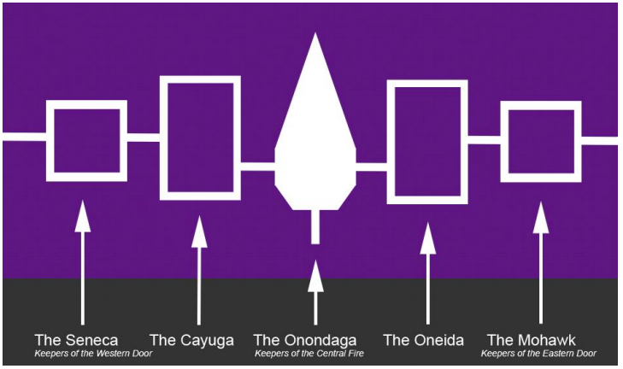
Appendix 1.

Principal’s Task Force on Diversity, Excellence and Community Engagement, “Final Report,” https://www.mcgill.ca/principal/sites/mcgill.ca.principal/files/ptfdece-reportfinal.pdf, 24.
Aboriginal Affairs and Northern Development Canada, https://www.aadnc-aandc.gc.ca/eng/1100100013704/1100100013705.

