Report of the VP External
Wednesday, September 3rd 2014
Submitted by Lola Baraldi

Intro
Bonjour/Hi, friends!! I’m super excited to be working with all of you this year. I hope your summer was absolutely awesome and that you’re well ready to tackle on this year together!

Portfolio reminder (keep me accountable, yo! :)
-Community Engagement
-Partnerships & Sponsorships
-Liaising AUS with other student groups and associations (ex. SSMU) and alumni (DAR)
-Career & post-graduate prospects (work your B.A., Grad Fair…)
-Chair the Arts Community Engagement committee & the Sponsorship Committee

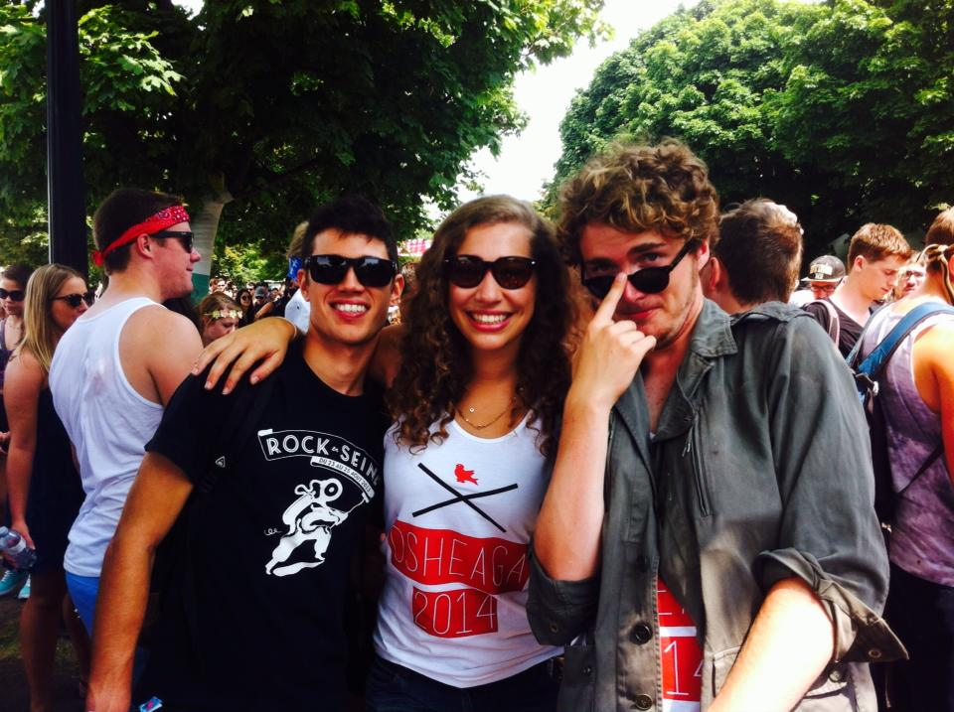
Summer update

I stayed here (almost) all summer, it was awesome! I got to meet with a couple sponsors in advance, and also campus offices / groups, such as SEDE, Campus Life & Engagement, CaPS, and our new harm reduction officer.

Community Engagement

- Community Engagement Day - Thursday October 2nd
SUPER EXCITING LIST OF PROJECTS THIS YEAR!! .
AUS is subsidizing two projects this year, the Afghan Women's Center one and the Yellow Door one.
It would be great to get as much AUS involvement as possible – several of us are already going to volunteer and facilitate a project, and you should too! You can choose to get involved by either facilitating or just attending a project. Check out http://ced-mcgill.format.com for more info + registration and e-mail them ASAP if you would like to facilitate!

- AUS & SEDE (Social Equity & Diversity Education Office)

I met with SEDE over the summer and once more recently with Ava. We talked about ways in which we can strengthen ties between SEDE & AUS. I am going to meet with them again soon to talk about a crowdsourcing project organized by ArtsDAR that we are going to brainstorm about. I also want to try and have a SEDE rep on ACE committee. Looking forward to increasing collaboration with them!

- ECOLE

Ava & I met with ECOLE to talk about collaborations. The meeting went very well – we advised them to touch base with AUSec to perhaps organize a social event/meet and greet sort of thing at the ECOLE house. I also really want to organize a workshop in the lounge on how to live a sustainable life in an apartment in Montreal, so keep your eyes out for that!

- Campus Life & Engagement

Worked with them to set up a popcorn stand during Engage McGill, by donation & all proceeds directed to a local charity, The Breakfast Club.

- Look out for ACE committee call outs coming out soooooon!

Career & Post-Graduate Prospects

- Grad Fair
AUS & SUS Grad Fairs will be back to back this year, we will be on Tuesday November 4th. We're doing it a bit later so we can hold it back to back with Concordia, it makes sense for schools going to both. Planning has been going pretty well so far, I’ve been approving schools and checking in with CaPS. Meeting with SSMU security on Monday to touch base with them about everything.

- Work Your B.A.
Ava & I met with CaPS last week to get the ball rolling. Rooms are in the process of being booked, and a committee will be set up shortly to brainstorm events.

Consent Campaign & Harm Reduction initiatives

We have a new Liaison Officer for Harm Reduction, yay! I met with her during the summer and she’s great – we brainstormed a bit on what harm reduction initiatives AUS could take on this year, so if you have ANY ideas (workshops, campaigns, forums, events…) let me know, it could happen.
There is going to be a cross campus campaign about consent in October, 2014. The next working group to discuss the planning of this will be TOMORROW, from 2:30 to 3:30 room 430 at 3610 McTavish. Super excited!

Sponsorships & Partnerships

In talks with previous sponsors to renew contracts, meeting with sponsorship coordinators at some point next week.

That’s all, folks! Ask me anything.
Respectfully submitted,

Lola Baraldi

