Preamble:

In the 2013 – 2014 term, the AUS Financial By-Laws were amended so that future AUS Executives eligible for Work-Study can be compensated at minimum wage for up to a maximum of 10 hours a week through the Work-Study program. The minimum wage is $10.35 and $10 of the hourly wage is reimbursed by Work-Study while $0.35 is drawn from the AUS operating budget. In September 2014, the AUS VP Finance discovered that the amount allocated by the Work-Study Program to each AUS Executive for the 2014 – 2015 school year is 320 – 360 hours a semester, which is 20 hours a week. The VP Finance brought the issue to the Executive Committee for the financial bylaws to be amended so that executives may be allowed the full amount allocated to them by the Work-Study Program. The original 10 hour cap was set out of concern that AUS Executive pay might drain the Work-Study funds, However, because it is the Work-Study program that decided on the current allocation, the current executive feel like this concern is no longer valid and have thus brought forward this motion to council for by-law revision.

Motion to Amend the AUS Financial Bylaws

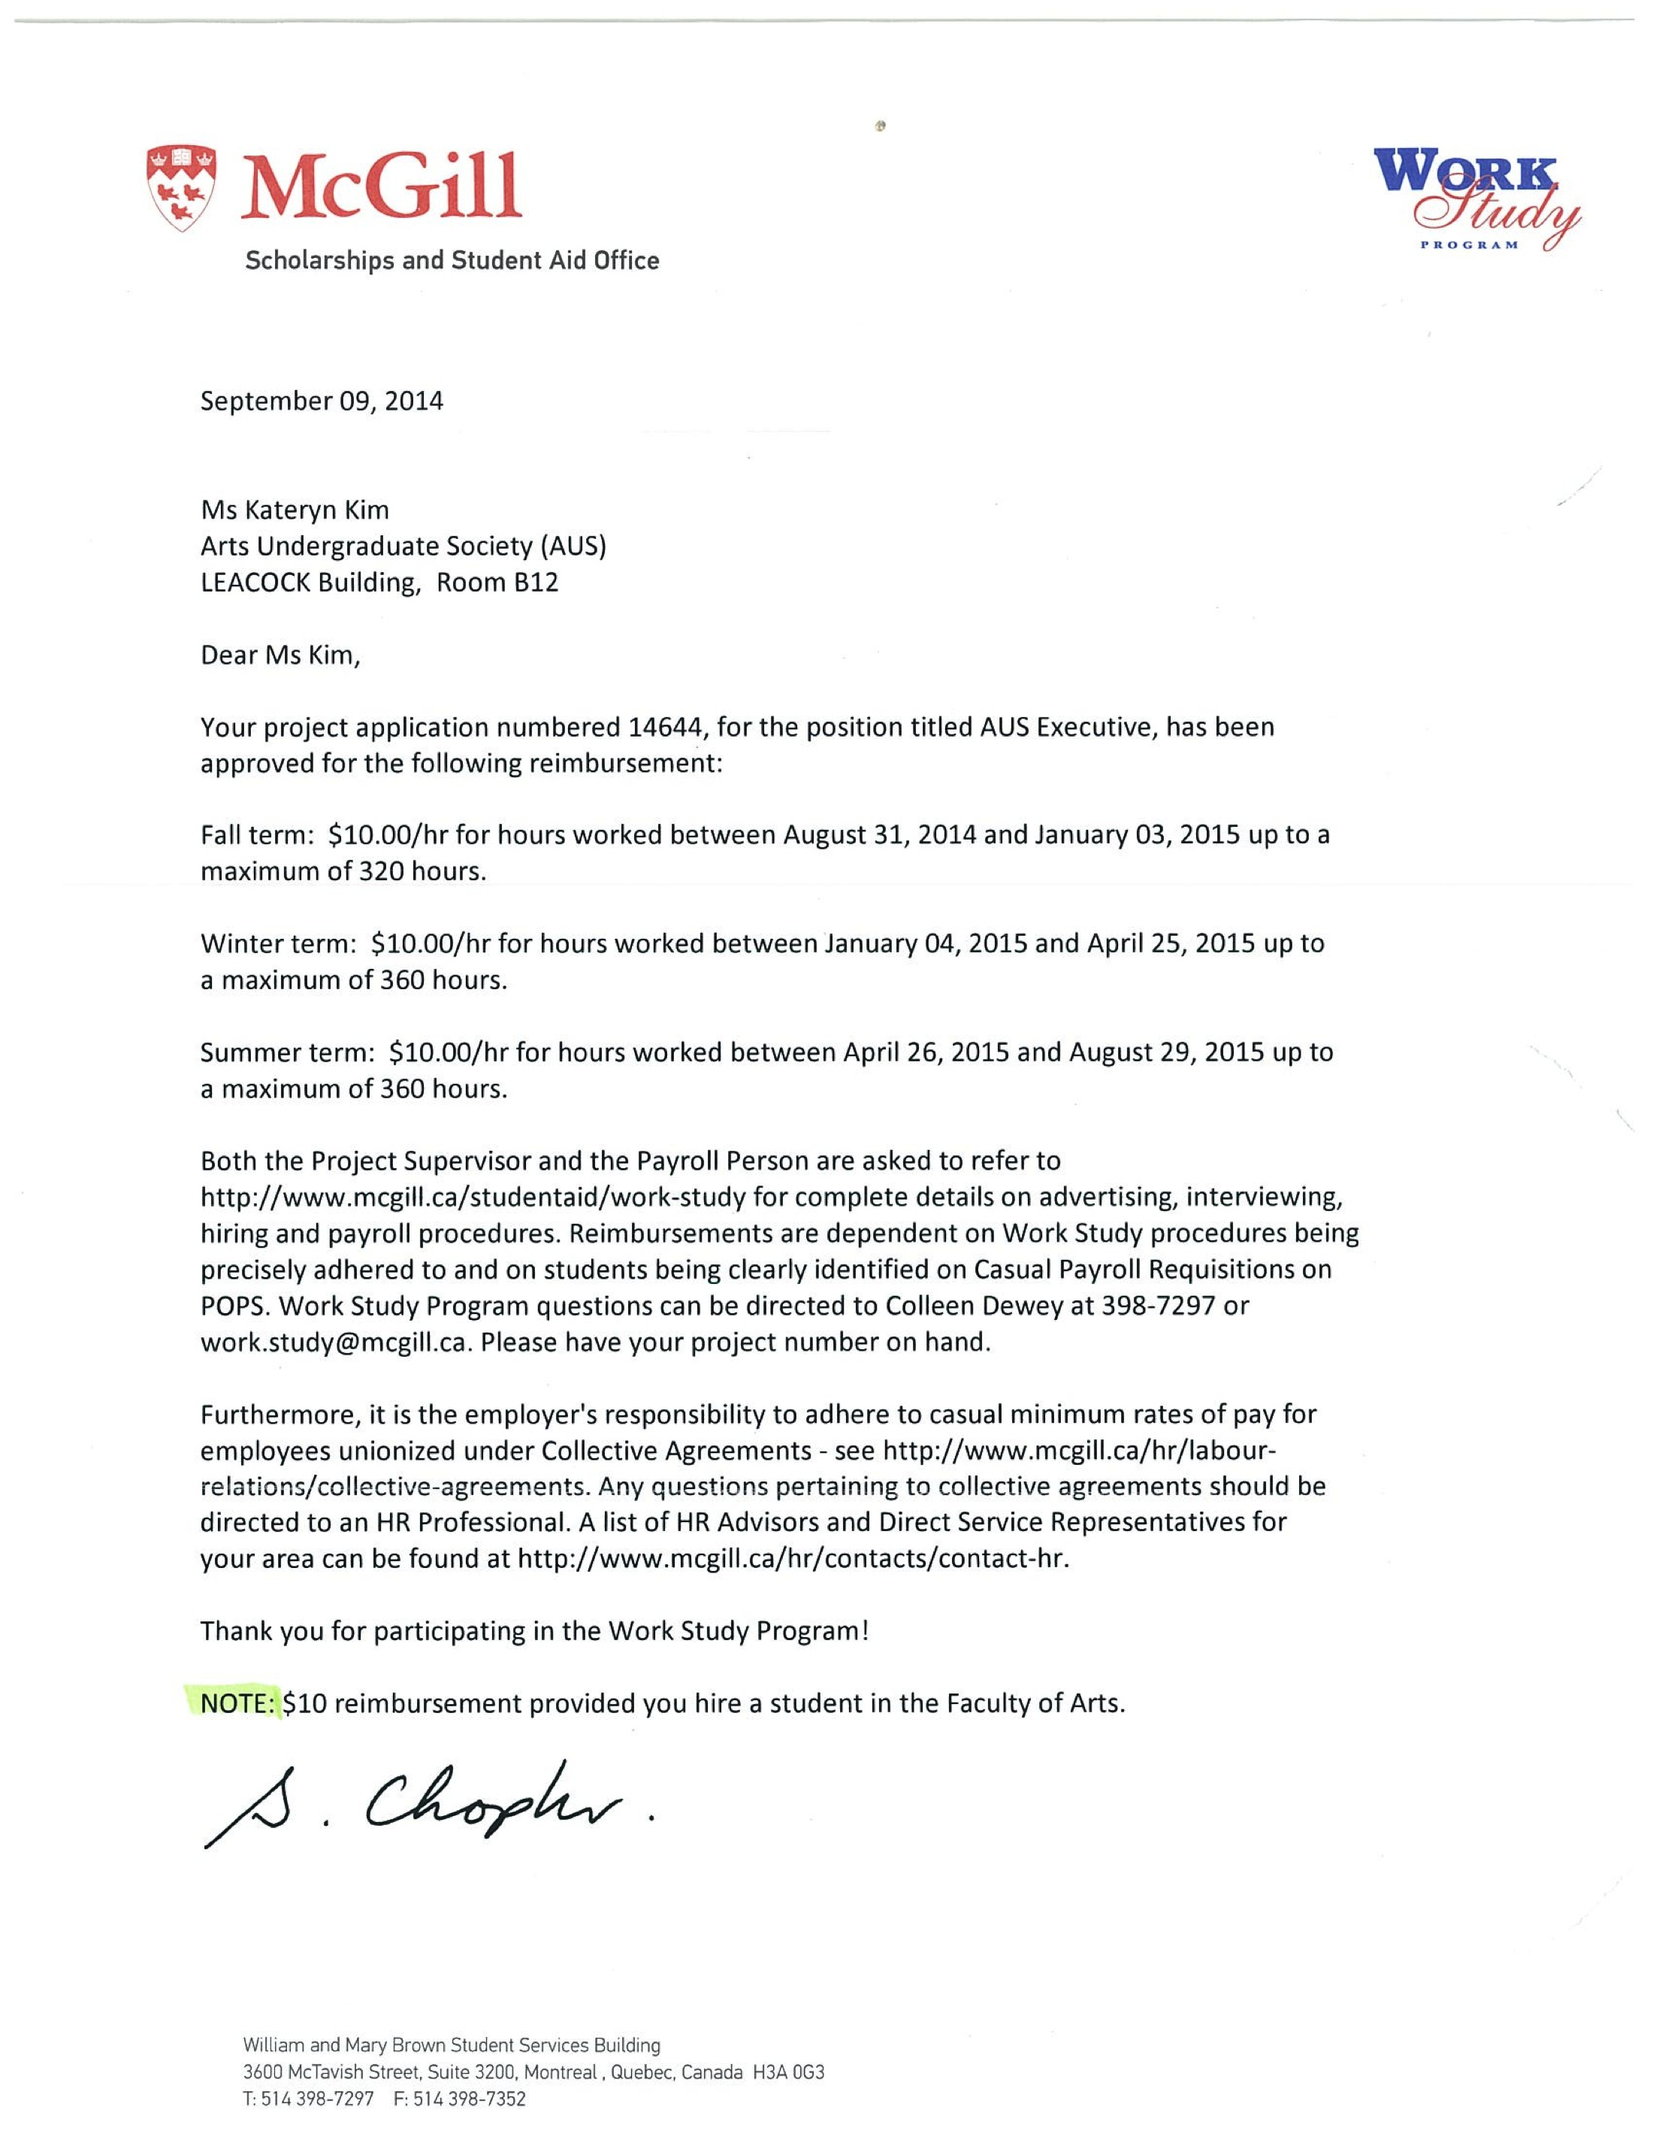

Whereas the Work-Study Program has approved the position of “AUS Executive” for up to twenty hours of remuneration per week, for which the Work-Study program reimburses the AUS $10.00 per hour worked;

Whereas only $0.35 of every hour worked by an AUS Executive comes out of student fees via the AUS operating budget, the exact range of effect which can be observed in the following chart,

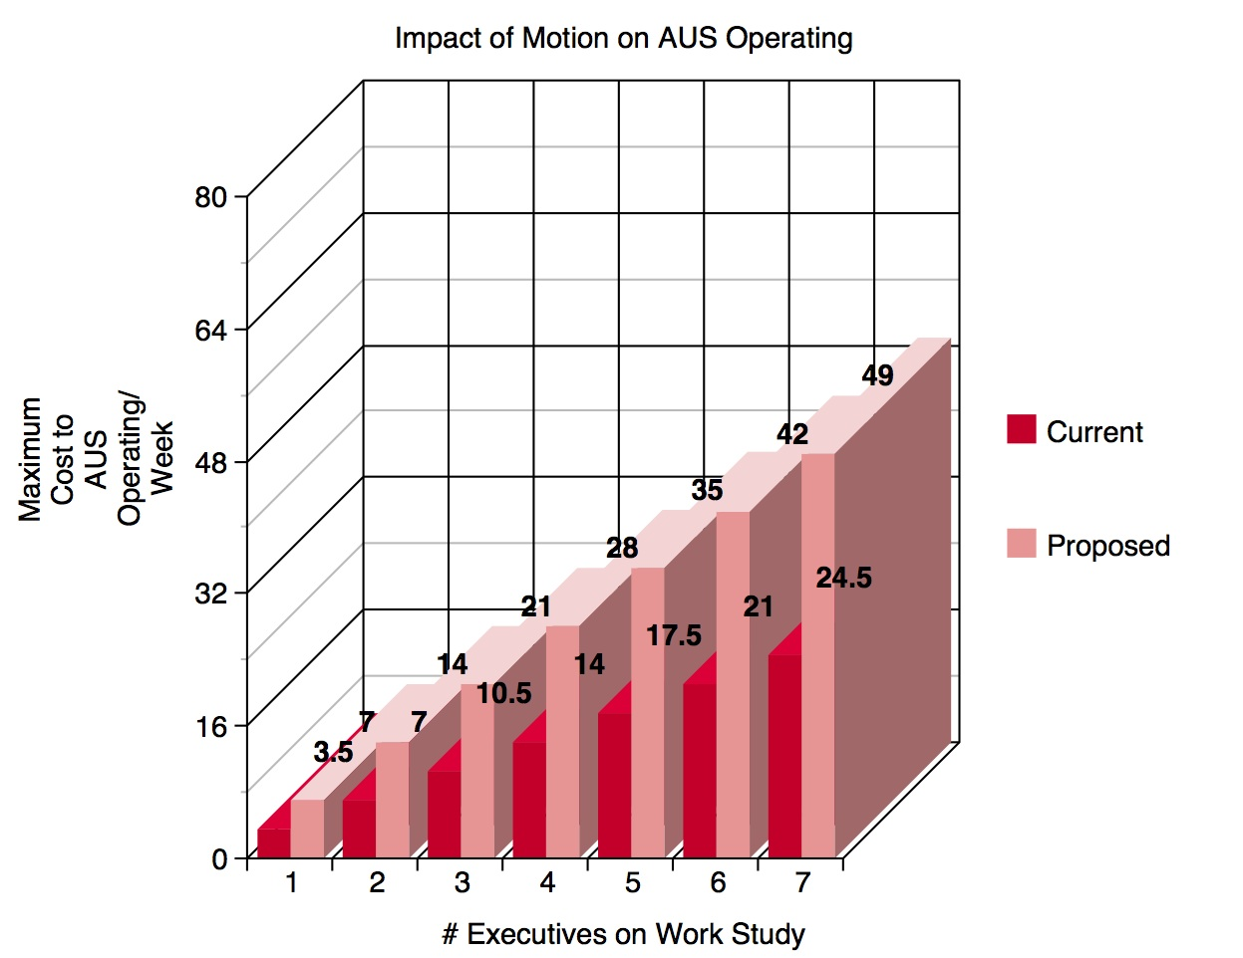

Whereas Work-Study eligible members of the AUS Executive are currently capped at being paid for up to ten hours of work per week per the financial bylaws;

Whereas members of the AUS Executive consistently dedicate a significantly larger amount of time to their portfolios;

Whereas the 10 hour cap set for the AUS Work Study under the current financial by-laws is arbitrary and whereas the new limit is the set amount as approved by the Work-Study program, an external party to the AUS Executive Committee.
Whereas Article 1.4 of the AUS Equity Policy states that:
1.4. The AUS understands that historically and culturally disadvantaged groups and persons are subject to systematic marginalization and oppression, based on ascribed or asserted characteristics related to personal aspects including, but not limited to, gender identity, age, race, ethnic or national origin, religion, sexuality, sexual orientation, mental and/or physical abilities, language, size, or social class.
Whereas the issue of pay is one of financial equity due to its bearing on social class and financial accessibility,
Whereas changing the financial by-laws to reflect the Work-Study allocation will improve the financial accessibility of the AUS Executive position,
Whereas the AUS Executive contacted the members of AUS Council in the form of increasing accountability,
BE IT RESOLVED THAT that the AUS Financial Bylaws be amended to reflect the Work-Study allocation as follows:

Article 9.1.1 to be changed:
From: “AUS Executives who are Work Study eligible shall be paid at minimum wage for
a maximum of ten (10) hours per week.”
To: “AUS Executives who are Work Study eligible shall be paid at minimum wage for
a maximum of twenty (20) hours per week.”

BE IT RESOLVED THAT only operational mandates of the AUS Executive will be eligible for pay, to the specific purpose of ruling out two representative settings: AUS Council and SSMU Council, both of which will not be eligible for compensation.

Moved By
Li Xue, AUS VP Finance
Eddie Lin, Arts Representative to SSMU
Patrick Dunbar-Lavoie, Arts Representative to SSMU
Lola Baraldi, AUS VP External
Kyle Rouhani, AUS VP Social
Leila Alfaro, AUS VP Internal
Ava Liu, AUS President
Bianca Waked, Philosophy Students’ Association

More information on the funding in the Work-Study program: half of the Work-Study funds consists of the annual student contribution to the Arts Student Employment Fund (ASEF), and the other half which is matched by the university. ASEF is one of the AUS’ student fees.

