Motion to Amend the AUS Financial Bylaws

Whereas the McGill Work Study Program has approved the position of “AUS Executive” for a certain number of hours of remuneration per week at the beginning of every fiscal year;

Whereas the McGill Work Study Program reimburses the AUS at a weekly rate of $10.00 per executive per hour worked, half of which comes out of student fees via the AUS Work Study Program;

Whereas an additional $0.35 for every hour worked by an AUS Executive comes out of student fees via the AUS operating budget;

Whereas the Work-Study funds are meant to be allocated to students who currently hold Work Study status;

Whereas all eligible members of the AUS Executive have obtained Work Study status as the result of a standard evaluation process completed by staff members of McGill University with access to information outside the purview of AUS Councillors;

Whereas Work Study-eligible members of the AUS are currently capped at being paid for up to ten hours of work per week as per Article 9.1.1. of the Financial Bylaws;

Whereas the current 10-hour cap set for AUS Executives is a number determined by the AUS Legislative Council in the 2013-2014 year, with the specific intention for payments to serve as a stipend;

Whereas this intention, though positive in spirit, fails to address a larger spectrum of financial need and does not necessarily lead to an outcome of financial accessibility;
Whereas AUS Executive positions should be filled by individuals with a desire to see the Arts Undergraduate Society flourish, regardless of their financial circumstances, and increased financial accessibility contributes to the overall sustainability of the Society;
Whereas the Work Study program independently regulates reimbursement and sets caps on hours as necessary, based on the nature and funding of positions;

Whereas members of the AUS Executive dedicate a significantly larger amount of time to their portfolios in order to meet the operational and representative requirements of their portfolio;
Whereas amending the Financial Bylaws to reflect the yearly Work Study allocation will improve the financial accessibility of AUS Executive positions;
Whereas the potential financial impact of this amendment has been discussed with and approved by the Work Study Program Administrator;
Whereas suggestions from AUS Councilors have been implemented to increase the accountability and transparency of AUS Executive positions, including posting schedules on a bi-weekly basis;
Whereas Article 1.4 of the AUS Equity Policy states that:
1.4. The AUS understands that historically and culturally disadvantaged groups and persons are subject to systematic marginalization and oppression, based on ascribed or asserted characteristics related to personal aspects including, but not limited to, gender identity, age, race, ethnic or national origin, religion, sexuality, sexual orientation, mental and/or physical abilities, language, size, or social class.
Whereas the maintenance of the current cap on hours is problematic in the context of Article 1.4 of the AUS Equity Policy;
BE IT RESOLVED THAT the AUS Financial Bylaws be amended to reflect the Work-Study allocation as follows:

Article 9.1.1 to be changed:
From: “AUS Executives who are Work Study eligible shall be paid at minimum wage for
a maximum of ten (10) hours per week.”
To: “AUS Executives who are Work Study eligible shall be paid at minimum wage for a maximum number of hours per week as determined by Work Study each year.”

BE IT RESOLVED THAT only operational mandates of the AUS Executive will be eligible for pay, to the specific purpose of ruling out two representative settings: AUS Council and SSMU Council, both of which will not be eligible for compensation.

Moved By:

Bianca Waked, Philosophy Students’ Association
Erin Sobat, AUS VP Academic
Max Drabkin, AUS VP Communications
Patrick Dunbar-Lavoie, Arts Representative to SSMU

Appendix 1 – Overview of the Arts Student Employment Fund

The Arts Student Employment Fund (ASEF) supports career-advancing and/or academically-based employment opportunities for Arts undergraduate students. These include Research Assistant positions with professors within the Faculty of Arts, as well as various other employment opportunities with other units across campus.

The ASEF is made up of the opt-outable Arts Student Employment Fund Fee of $6.50 per semester for full-time students and $3.25 for part-time students (code “AUGE” on Minerva). Half of this fee contributes to the Arts Faculty Employment Fund, which provides funding to new professors for Research Assistants and is matched by the Faculty of Arts. The other half of the fee contributes to the AUS Work Study Program, which provides partial funding for Research Assistants and other positions and is matched by McGill University through the Scholarships and Student Aid Office.

Each half of the fund totals approximately $84 000 each year, including the matching contribution.

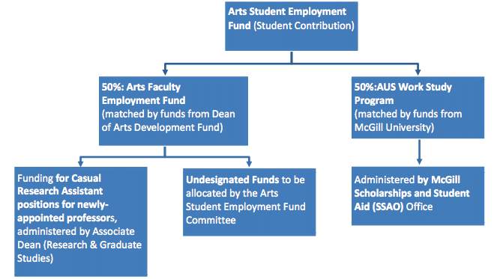

The Fall allocations of the Undesignated Funds are available here. For more information, please see the ASEF FAQ and Fund Bylaws.

Appendix 2 – Financial Report on the AUS Work Study Program

The numbers below represent the yearly contributions and allocations of the student contribution to the AUS Work Study Program. These funds are matched by McGill University in their reimbursement allocations: for example, a $10 reimbursement will consist of a $5.00 contribution from students and a $5.00 contribution from the University. Thus, the real value of the Fund in a given year is twice the “AUS Contribution”.
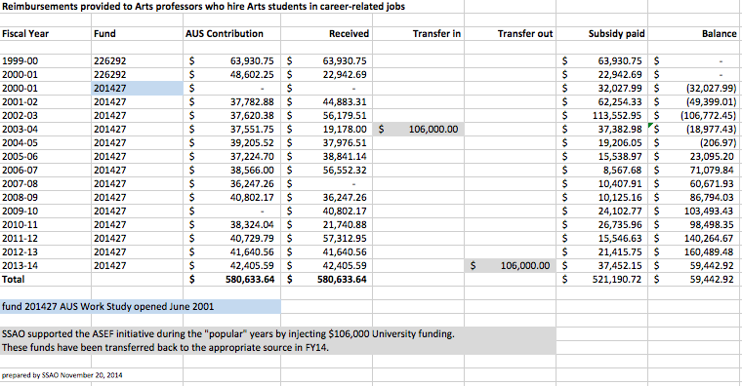

Appendices 1 & 2, Overview of the Arts Student Employment Fund & AUS Work Study Program
“Information for Students – Work Study”, Scholarships and Student Aid website
Financial Bylaws, AUS website
Section f, Minutes of AUS Legislative Council, January 15, 2014, AUS website
Phone conversation between the AUS VP Academic and Sandy Chopko, Work Study Administrative Officer, November 21, 2014
Ibid.
Motion Regarding Accountability of AUS Executives, AUS Legislative Council, October 15, 2014

