Motion to Approve Arts Student Employment Fund Allocations

Whereas the Arts Student Employment Fund Committee (ASEFC) met on November 6, 2014 to review and make decisions on applications to the undesignated funds of the Arts Student Employment Fund (ASEF);

Whereas Article 5.6 of the ASEF bylaws states that “Allocations decided by the ASEFC must be approved by a majority vote of AUS Legislative Council”;

Be It Resolved, that AUS Legislative Council approve the following allocations of the undesignated funds of the Arts Student Employment Fund:
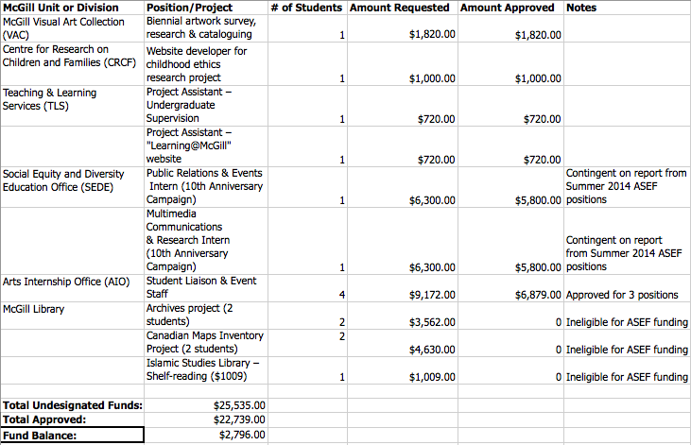
Moved by:

Erin Sobat, AUS VP Academic
Sue Jeong, EASSA VP External

