Office: (514) 398-1993
Fax: (514) 398-4431
http://www.ausmcgill.com
Arts Undergraduate Society of McGill University
Office of the Vice-President (Communications)
855 Sherbrooke Street West
Leacock B-12
Montreal, Quebec H3A 2T7

Council Report of the AUS President
Wednesday, November 26th, 2014
Submitted by Ava Liu
Intro
Work Study and Equity
I have spoken to the Executive Committee about the Equity and Work Study issues. I know that there has been some confusion over the events that transpired. As of last Executive Committee, Arts Rep Dunbar-Lavoie, VP Communications Drabkin, and VP Academic Sobat are working on presenting a complete account of information obtained from Work-Study regarding how they operate. The information should explain how the funds from ASEF are allocated to Work-Study.
Personally, I have given this a great deal of thought. I believe that I support the removal of the cap from the AUS Financial By-Laws not only for the purpose of increasing financial accessibility, but because I believe that our internal AUS by-laws are not the appropriate place for the cap. The cap sets up a tense and difficult relationship between executives and councilors as councilors are now responsible for preventing executives in financial need from accessing the hours allocated by Work-Study, especially since the Work-Study portion is not designated as a salary and it is only available to executives in need. Any consideration for a cap, if instated, should be kept within Work-Study’s body of institutional memory and should be considered by Work-Study when they allocate hours to the AUS. In the future, Work-Study should only give the number of hours that they deem available with considerations, and considerations brought forth from AUS council regarding executive pay can be brought in here, but that should be the extent of contact between Work-Study and the AUS. If Work-Study deems that there is enough funding in the ASEF fund and the general Work-Study fund that semester, then AUS Council is in a difficult and unnecessary position if our internal by-laws prevent our constituents (which include our Executives, since Executives are also working Arts students eligible for Work-Study) from accessing their funds. Thus, the cap for the pay should not be kept within our internal by-laws, but should be kept within Work-Study by-laws. This is especially true in the context of Executive positions such as the VP Finance’s portfolio, which are almost entirely operational. The AUS operates without a bookkeeping department, which is typically an external department that most non-profit corporations, including SSMU and MUS, employ. A bookkeeping department is an external, professionalized service that we lack. The AUS VP Finance is the sole chief of the AUS’s internal bookkeeping department and is responsible for liaising with our auditors. These are extremely serious responsibilities that would typically cost a non-profit corporation of our magnitude more than many thousands of dollars per year. The scope of the legal and financial liability resting with our internal bookkeeping department is huge and far extends beyond a “volunteer” position of even 20 or 30 hours a week at minimum wage. There is quite frankly, no way, that a Work-Study stipend even if paid to the hour up to 40 hours week can match the amount of work and liability the AUS as a non-profit corporation addresses in its operations. This is my final opinion on the matter and I hope to see the motion to lift the cap removed.
1. Dean’s Fee
Town Hall is happening this week at council. I hope to see enough agreement here today to pose a referendum question in the new semester.
3. HR Review
Convening today at council.
4. MoA Negotiation and SNAX
Update from Ollivier Dyens regarding his policy. (See VP External and Arts Reps’ reports for more info). Also see Trib article.
SNAX is selling chicken biryani for $5!!!
Events and Other Projects
Laptop Lending Program
Sent out listserv about this. It is operational.
Fine Arts Council By-Laws
Will update orally.
Mural
SQ
Work Your B.A.
Going very well. Full schedule available.
Elections and Referenda
Happening now.
Other updates
Not going to go on vacation! Will be here for council first week of January. Will update you all on new council room dates.
Timesheet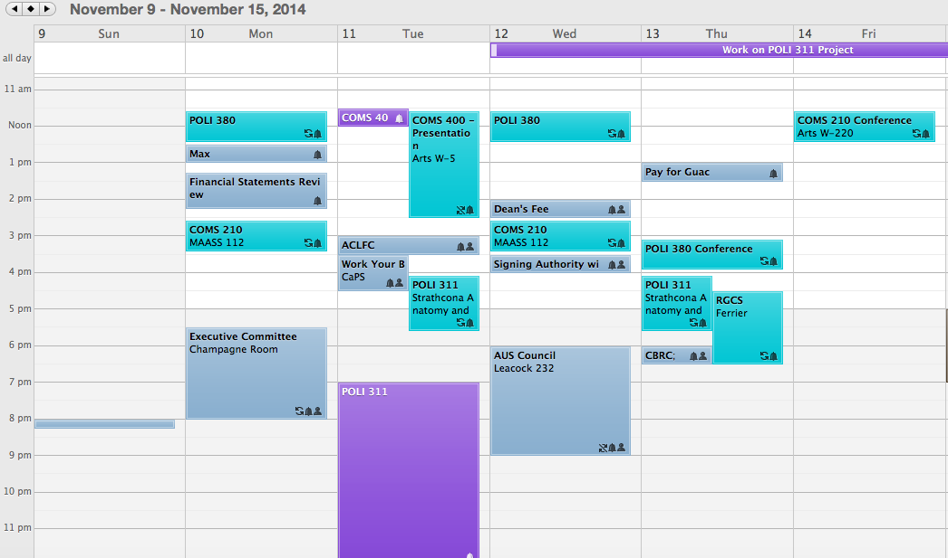

Respectfully submitted
------
Ava Liu
President | Présidente
Arts Undergraduate Society (AUS)
L'Association Étudiante de la Faculté des Arts (l'AÉFAPCUM)
(514) 398-1993 | http://www.ausmcgill.com

The Arts Undergraduate Society of McGill University is a student association accredited by the gouvernement du Québec (R.S.Q. Ch.A-3.01).

