Motion to Approve Arts Student Employment Fund Summer Allocations

Whereas the Arts Student Employment Fund Committee (ASEFC) met on February 27, 2015 to review and make decisions on applications to the undesignated funds of the Arts Student Employment Fund (ASEF);

Whereas Article 5.6 of the ASEF bylaws states that “Allocations decided by the ASEFC must be approved by a majority vote of AUS Legislative Council”;

Be It Resolved, that AUS Legislative Council approve the following allocations of the undesignated funds of the Arts Student Employment Fund for projects beginning in Summer 2015:
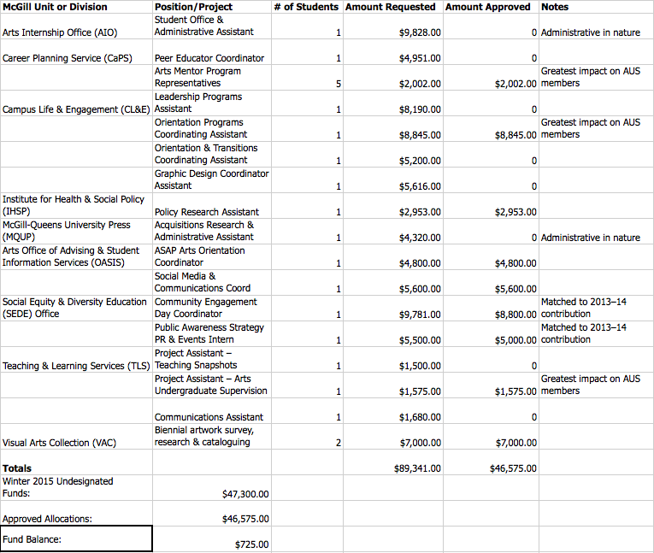

Moved by:

Erin Sobat, AUS VP Academic
Sue Jeong, EASSA Representative

