Arts Senator Report to AUS Council

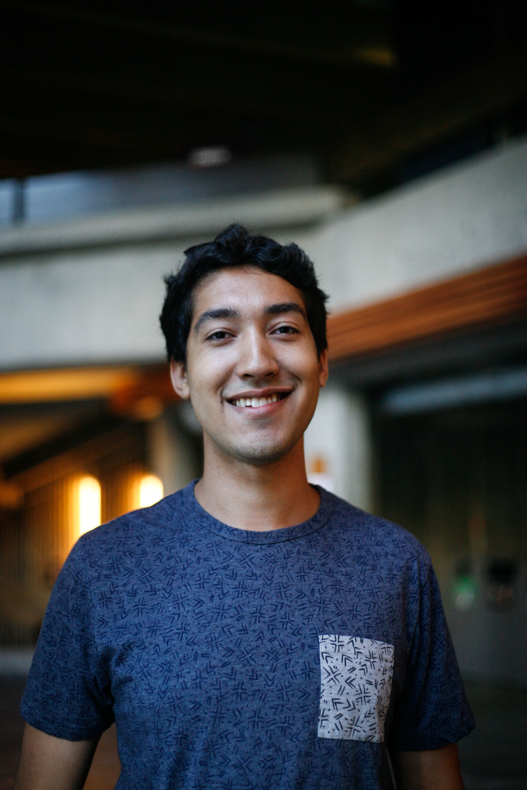

Introduction

I’m Alex Kpeglo-Hennessy, one of your two Arts Senators. I’m a U3 student in Honours Political Science with a minor in Psychology from British Columbia. If you have any questions about my role feel free to contact me! My office hours will be finalized by mid-September. I sit on the following committees and each heading has an excerpt from their terms of reference that explains their purpose. I should be receiving email access soon at artssenator1@ssmu.mcgill.ca.

Senate

- Senate
  - Highest governing body at McGill after the Board of Governors; 113 members including 21 student representatives
  - This year’s first meeting is Thursday, September 24th
  - Asking questions regarding illegal executive pay raises (http://tinyurl.com/p3pojhw), physical accessibility in building renovations, & McGill responses to the Truth and Reconciliation Report
- Senate Caucus
  - Undergraduate Senators meet weekly to discuss Senate documents, committee updates & shared projects
- Committee on Student Grievances
  - “Any student has a right to lodge a grievance resulting from an act or a failure to act by a member of the University occupying a position of authority vis-à-vis the student in a University-related matter” and this committee adjudicates this process
  - I have required training the first week of October
- Subcommittee on Queer Equity
  - “The McGill Equity Subcommittee on Queer People is a subcommittee of the McGill Joint Senate-Board Committee on Equity that addresses issues of representation, inclusion and support of lesbian, gay, bisexual and transgendered students, staff and faculty at McGill with respect to academic and non-academic life on campus”
  - The first meeting is TBA
- Advisory Committee on the Charter for Student Rights
  - “The Council [on the Charter of Students’ Rights] shall investigate any allegation that the general application of a University rule is in violation of this Charter.”
  - SQ
- Subcommittee of the APC on Teaching and Learning
  - “Recommend to the University through the Academic Policy Committee (APC) initiatives to enhance the quality of teaching and learning.”
  - This committee is working on revising its structure to achieve more concrete goals and to reduce its size
  - The first meeting is October 8th

AUS

- Waiting to find out the committee(s) to which I have been assigned

BASiC

- Due to the structure of senate elections there is no Arts & Science Senator this year
- Erin and I met with the SSMU VP UA, Science Senator, and representatives from BASiC to discuss needs specific to these students including student space and advising services
- Will be attending Arts Sci Assembly on rotating basis; meeting schedule still TBA

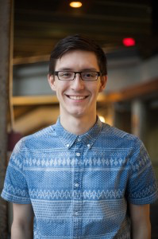

Introduction

Hi, I’m Erin Sobat, your other Arts Senator! I’m entering U3 in History, East Asian Studies and Classics, and am very excited to be representing Arts undergraduate students on McGill Senate and its committees this year. I’ll also be sitting on SSMU Council as a Senate Caucus Representative, and liasing with BASiC via the Arts Sci Assembly. Below is a summary of my committees and responsibilities not already covered above. You can get in touch anytime at artssenator2@ssmu.mcgill.ca.

Senate

- Academic Policy Committee (APC)
  - Standing committee responsible for making recommendations to Senate on academic policy; most proposals go through APC before reaching Senate
  - First meeting Thurs, Sept 17
- Enrolment and Student Affairs Advisory Committee (ESAAC)
  - Responsible for a number of policies & initiatives; projects include revision of Student Academic Assessment Policy & improved medical note policies
  - First meeting Tues, Sept 8 (will report orally)
- Committee on Student Services (CSS)
  - Advisory to the Senior Director of Student Services on objectives & priorities for service units; projects include Student Services funding, fee equity & service wait times
  - First meeting TBA
- Senior Director of Student Services Search Committee
  - Met & interviewed candidates over the summer; recommended candidate withdrew application, so now back to square one
  - Next meeting TBA

SSMU

- SSMU Council
  - Highest legislative body of SSMU after the General Assembly
  - Serving as one of three Senate Caucus Representatives on SSMU this year
  - SSMU Retreat this weekend Sept 11-13; first meeting Thurs, Sept 17
- SSMU Nominating Committee
  - Responsible for selecting certain hires as outlined in the SSMU bylaws
  - Met twice in August to approve shortlist and hires for Elections SSMU and Judicial Board positions
  - Next meeting TBA
- SSMU Bylaw Review Committee
  - Responsible for reviewing proposed new “Internal Regulations” before these are sent to SSMU Council for approval
  - First meeting TBA
- “Know Your Rights” Working Group
  - Working on review of Student Academic Assessment Policy, Charter of Student Rights, and student rights outreach, among other projects
  - Will be issuing a callout & contacting past members shortly
AUS

- Faculty of Arts Meeting
  - Caucus of all Faculty members; meets to approve Faculty business & hear updates from the Deans
  - First meeting Tues, Sept 29
- Curriculum Committee
  - Reviews proposals for new or revised programs & courses in the Faculty
  - First meeting Mon, Sept 14
- Dean of Arts Search Committee
  - Met in July & early September to define position profile & begin soliciting applications; looking to have an announcement by January 2016
  - Next meeting Wed, Oct 7

Respectfully Submitted,

Alex Kpeglo-Hennessy
Erin Sobat

