VP Academic Council Report September 23

AUS retreat was a blast! Here is a picture where I look like a bully:

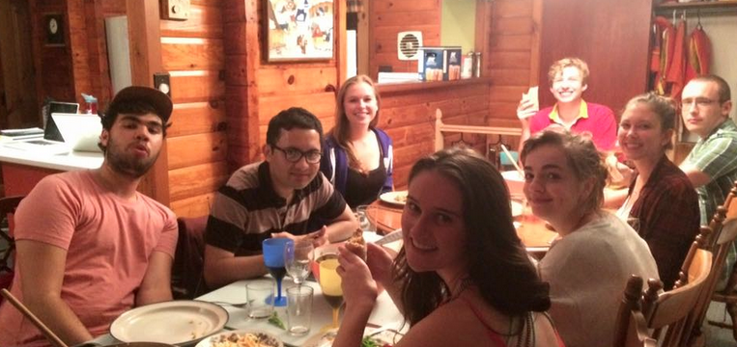

Departmental Orientation
Departmental Orientation is happening on Monday the 21st. I will report orally.

Essay Centre
Met with the Essay Coordinators to kick off the year and set goals and objectives (we also readjusted the budget). We have been recruiting tutors until the 21st of September and we have received 25 applications for 15 spots! I will be meeting the coordinators in 2 weeks to see how things are going.
Here are the Essay Centre drop-in hours:
- Mondays, Wednesdays and Fridays from 2:30-3:30
- Tuesdays and Thursdays from 11:30-12:30

Please inform your executives and (most importantly) your constituents about the Essay Centre drop-in hours! Appointments can also be made by emailing: aus.essay.centre@gmail.com

Peer tutoring
I will be following last year’s model of funding. Callouts for Peer tutoring funding have been sent on the 21st of September and I will be explaining the process (especially relevant for departments that have not benefited from the fund in the past) at departmental orientation. Departments will have until 29th to submit their applications.
If your department in interested in receiving funding and/or if you want information on how to launch a mentoring/tutoring program for your department, please contact me!

Faculty Committees/ Program Committees
Still looking for spots on the following program committees:
- African Studies (2)
- North American Studies (2)
- Quebec Studies (2)
- Women's Studies (2)
- Indigenous Studies (2)

There is still 1 spot left on the Faculty of Arts Council !! Let me know ASAP if you would like to sign up for it (or if you know anyone potentially interested).

Portfolio Committees
I am still looking for 1 Councilor to join the Library Partnership Committee and I still have 2-3 spots open for the Academic Affairs Committee. I want to form those committees as soon as possible; so please contact me if you are interested and I will sign you up them! Please keep in mind that if you are a Councilor, these committees will fulfill your mandatory committee attendance.
All meetings time are TBD and the committees will most likely form at the end of September.

Archiving
I met with Faraz Oman, the Archiving Coordinator last Thursday (the 17th of September) and I have conducted a callout on our last listerv for 2 Archiving volunteers so if you are interested or know anyone that could be interested please let me know! Our aim to is to create institutionalized archiving within the AUS.
In the next couple of weeks your department will receive an email asking for more information about your journals and/or the plans for journals to keep tuned!
Please fill out this spreadsheet if you haven’t already:
https://docs.google.com/spreadsheets/d/1-YSAHwxt8KPMt0V6qXQm82HaVizUEAqn031-9TgGNFk/edit#gid=0

Networking
Last week I met with Catherine Stace from CAPS and Michael Fishman, the MUS VP Corporate Relations. These meetings gave me a good insight on how networking is done in other units on campus, and this is helping me generate more ideas on how I plan to execute the initiative.
I will also be coordinating with the VP External because there is a lot of overlap and because we both possess resources that will be invaluable.

Surveys
Please fill out the following survey: https://docs.google.com/forms/d/1J3aLuIjr_PlT-rAmPmJtmSDhoYGAoGjt11w_NRPPWak/viewform
The survey as been started by Brandy Jugandi from OASIS (as previously mentioned in my last report) and will provide OASIS (and by extension the AUS) with invaluable insight on student needs!

Meetings
- Met with Patrick Helfetry on 22nd September for the Arts Peer to Peer Research Symposium (APPRS). Will report orally.
- Met with AIO with Jacob last week. Talked about AIO Advisory Committee which should be forming sometime this semester. Will report on this later.
- Met with McGill Academic RoundTable (MART) on the 17th of Septmebre. Unfortunarely was on retreat couldn’t attend Student Academic Summit, will meet with Chloe Rourke (SSMU VP UA) to catch up sometime this week.
- Meeting with Associate Dean Engle Warnick to discuss ASEF this Friday.

Respectfully submitted,

Gabriel Gilling

