Arts Senator Report to AUS Council
October 7th, 2015

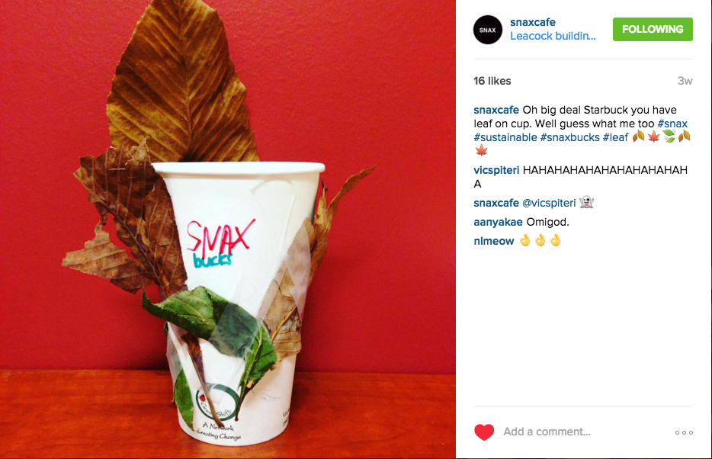
Shoutout to the @snaxcafe Instagram account, y’all should follow them!

Joint Projects
- Senate
  - Next meeting this Wednesday, October 21st (will report orally)
  - Submitted Question Regarding McGill’s Response to Current Refugee Crisis
  - The following items will be on the agenda:
    - Open Discussion on “McGill’s International Strategy”
    - Annual Report of the Academic Policy Committee
    - Annual Report Concerning the Investigation of Research Misconduct
    - University Advancement Annual Report
    - Annual Report from the Senate Committee on Physical Development
    - Report from the Board of Governors to Senate
- Senate Caucus
  - Discussed McGill executive pay report (http://tinyurl.com/nzotx38 – page 31), employment equity strategy, smoking policy, medical note issues
- Arts & Science
  - Alex attended BASiC Assembly on October 13th; Erin will attend October 27th
  - Projects: institutionalizing Arts & Science Senator position, funding improvements for Arts Sci scholarships, administrative & teaching resources

Alex Kpeglo-Hennessy

Senate
- Committee on Student Grievances
  - Waiting to hear back about the finalized date of the hearing I have been assigned to
- JBSCE Subcommittee on Queer Equity
  - Attended a meeting on October 13th
  - Topics discussed included
    - The annual LGBTQ homecoming event, Return to the Rainbow, this Friday
    - The committee’s nomination for an Honorary Degree
    - Employment Equity updates
- Advisory Committee on the Charter for Student Rights
  - SQ
- Subcommittee of the APC on Teaching and Learning
  - The first meeting was October 8th
  - A number of decisions have been sent to the APC for approval including
    - Amendments to the STL terms of reference
    - The creation of an Online Education Working Group
    - Clarifications to the guidelines for the Lifetime Achievement Award for Leadership in Learning
  - Had presentations on McGillX, Mercury Course Evaluations, and the upcoming TLS Symposium
  - Attended a smaller meeting with the Director of TLS and a TLS Academic Associate to discuss online learning tools on October 16th
  - TLS has a number of pilot projects in this domain and expect to institute a new SRS next fall
- Ad-Hoc Committee to Review the Charter on Student Rights
  - Waiting to hear back about the first meeting of this committee
- Advisory Committee on the Possible Reappointment of the Dean of Students
  - Waiting to hear back about the first meeting of this committee
- Committee on Student Services
  - Meeting next week that I have to miss due to a midterm
  - Next meeting is on November 12th

AUS

- Committee on Student Affairs
  - First meeting was supposed to be October 7th, however this has been cancelled
  - Next meeting will be November 11th
- Know Your Rights Working Group
  - Last Friday’s meeting was cancelled
- Accountability Committee
  - I am the Arts Senator sitting on this committee (as per its terms of reference)
  - No meeting dates have been set

SSMU

- Student Society Programming Network
  - Currently working on planning 4Floors (October 29th)
  - I’ve attended 3/4 meetings thus far

Erin Sobat

Senate
- Academic Policy Committee (APC)
  - Met briefly on Thursday, October 8th to approve business
  - Next meeting Thursday, October 29th
- Enrolment and Student Affairs Advisory Committee (ESAAC)
  - Met on Tuesday, October 6th
  - Update & discussion on Student Assessment Policy revisions, Fall Reading Break, medical note issues, Family Care Program
  - Next meeting Tuesday, November 3rd
- Committee on Student Services (CSS)
  - Next meeting Tuesday, October 20th
  - Likely disucssion around goals of new Interim Senior Director, Student Services internal unit review & Innovation Fund project reports
- Principal’s Task Force on the Royal Victoria Hospital Site
  - Met Tuesday, October 13th
  - Began fleshing out criteria for “academic vision” of the site; this will guide community consultation on which McGill units & services could see themselves moving to RVH if it is acquired
  - Next meeting Friday, October 30th
- Senior Director of Student Services Search Committee
  - Status quo pending further discussions with the Deputy Provost (see joint statement released by student associations: http://ow.ly/SRqO9)
- Library Master Plan Steering Committee
  - Sat on this committee last year; Master Plan results were released last week! Check out the proposal here: www.mcgill.ca/library/about/fiat-lux

SSMU
- SSMU Council
  - Met Thursday, October 15th
  - Approved VP FOPs Internal Regulations, CKUT & Safety Network fee Referenda, Yearbook fee & student-run cooperative plebiscites, Climate Change Policy, statement on satire, Law Library exam compromise
  - Next meeting Thursday, November 5th
- SSMU Internal Regulations Review Committee (IRRC)
  - Met on Wednesday, October 14th to review External Affairs IRs
  - Meeting this Wednesday, October 21st to review President & VP FOPs IRs
- SSMU Nominating Committee
  - Reported to SSMU Council on September 17th
  - Meeting to nominate new Deputy Electoral Officer sometime this week
- “Know Your Rights” Working Group
  - Chairing working group under the University Affairs Committee; emphasis on outreach & promotion around student rights
  - Had to cancel meeting on Friday, October 16th, currently rescheduling for this week or next
- University Affairs Committee
  - Responsible for overseeing research & advocacy priorities of UA portfolio, including advising on SSMU MoA negotiations
  - Currently finalizing membership, first meeting TBD very soon

AUS
- Memorandum of Agreement Working Group
  - Advising President & VP Finance on MoA negotiations with McGill
  - Currently a proposal is on the table to allow SNAX to sell sandwiches; negotiations will focus on reducing trade-offs (e.g. price controls)
  - President & VP Finance have a meeting with DPSLL on October 23rd
- Ad-Hoc Human Resources Committee
  - Working with AUS President to bring in more consistent HR policies for job descriptions, hiring & stipends
  - Secretary-General now hired, first meeting TBD soon
- Dean of Arts Search Committee
  - Met on Wednesday, October 7th to shortlist candidates for interviews in early December; looking to have announcement by January 2016
- Faculty of Arts Meetings
  - Met Tuesday, September 29th
  - Updates on Faculty of Religious Studies integration, School of Public Policy, budgetary situtation & space changes
  - Next meeting Tuesday, October 27th
- Curriculum Committee
  - Reviews proposals for new or revised programs & courses in the Faculty
  - First meeting this Monday, October 19th (can report orally)
- Humanities & Social Sciences Library Advisory Committee (HSSLAC)
  - Responsible for advising Head of McLennan-Redpath Library on policies for collections, services & user needs
  - First meeting this Friday, October 23rd
- Other Projects
  - Assisting KANATA on creating Indigenous Studies Students’ Association
  - Advising on review of departmental constitutions & GA procedures
  - Hope to contribute to discussions around VP Finance selection & training

Respectfully Submitted,

Alex Kpeglo-Hennessy, Arts Senator
Erin Sobat, Arts Senator

