Report of the VP Academic to the AUS Council – October 21st 2015

I took a step back from schoolwork and AUS work this past week for mental health reasons – don’t be afraid to do so as well! There are many resources out there (within and outside of McGill) to help you deal with your stress, issues and worries, so use them Here’s a picture of our fearless leader working in the shadows after our last council
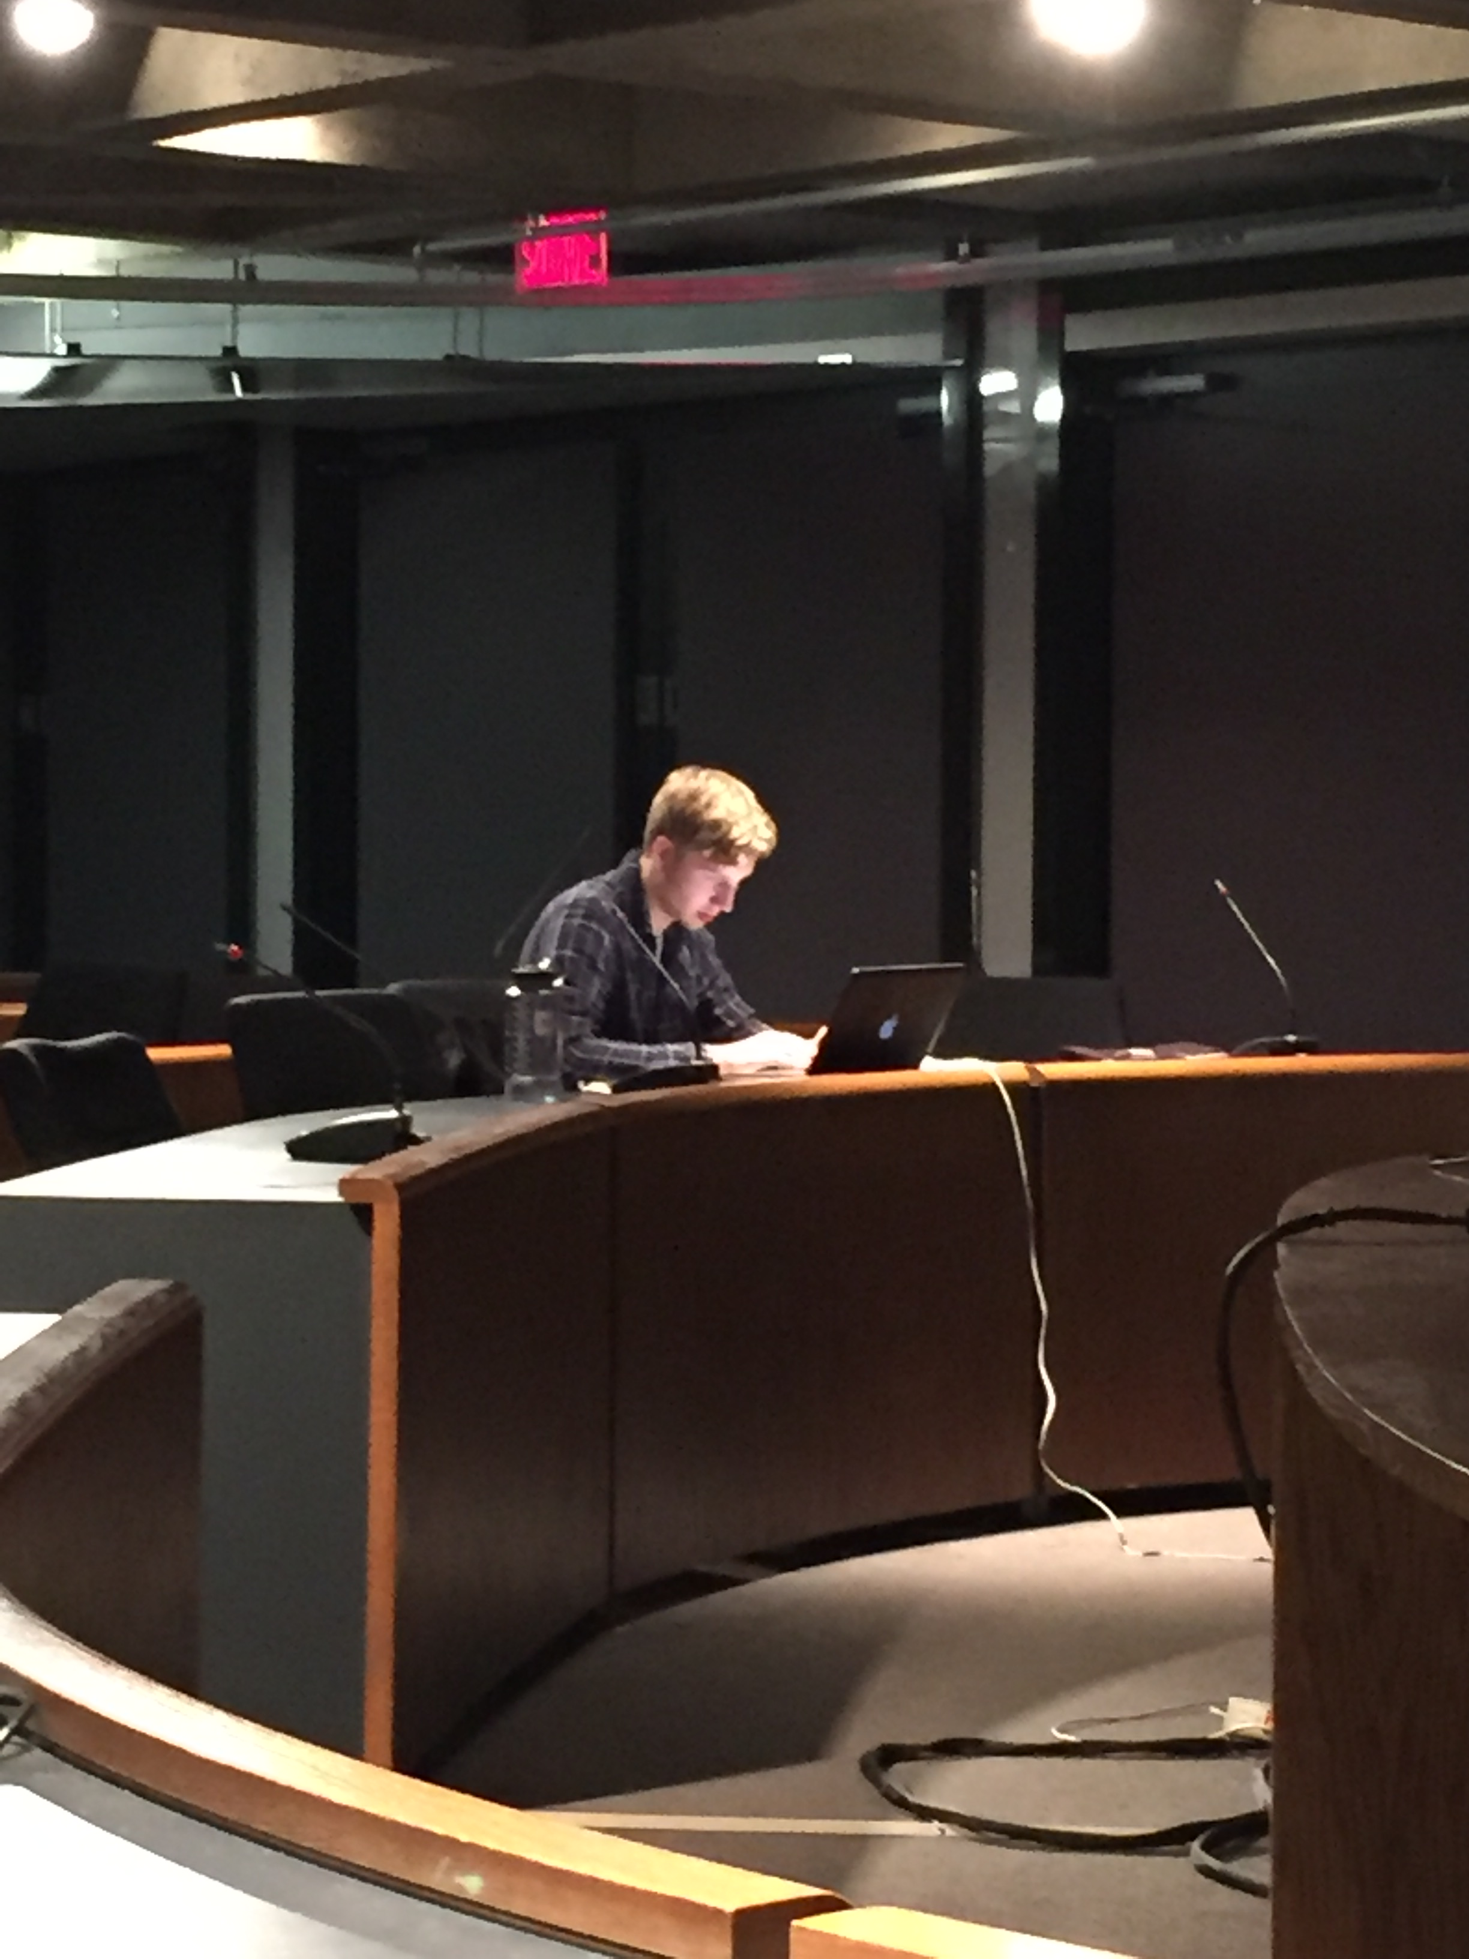
AUS- Library Partnership Committee
First meeting scheduled for sometime at the end of this week/early next week. I met with Robin Canuele, the interim head of the Humanities and Social Sciences Library last Friday to discuss how the committee worked and to talk about some of the plans for the year. He was very enthusiastic and had a lot of ideas for the committee – I predict this will be a good and fun year to work with him!

Academic Affairs Committee
Our first meeting will be held at the end of this week/early next week. I am getting the FEARC VP Academic to attend, which will be a nice introduction to the inner workings of the AUS for her. More on that next council.

Archiving
Met with Deena and Michael from the HSSL and I’m happy to say they’re really motivated about the project! They brought in a ton of exciting ideas and now our Archiving team has started working, so remind your VP Academics to reply as thoroughly as possible when Faraz Oman and his team send you emails. We are taking this very seriously and are trying to provide a service to all students so please have them check their emails carefully!

Curriculum Committee
The curriculum committee is meeting on Monday the 19th of October. Will report orally.

Arts Peer to Peer Research Symposium
After 3 weeks of callouts, I finally got someone to volunteer to be the second APPRS coordinator! We will meet sometime soon to make sure the event runs smoothly next semester!

That’s it for me!

Respectfully submitted,

Gabriel

