Arts Senator Report to AUS Council
November 4th, 2015

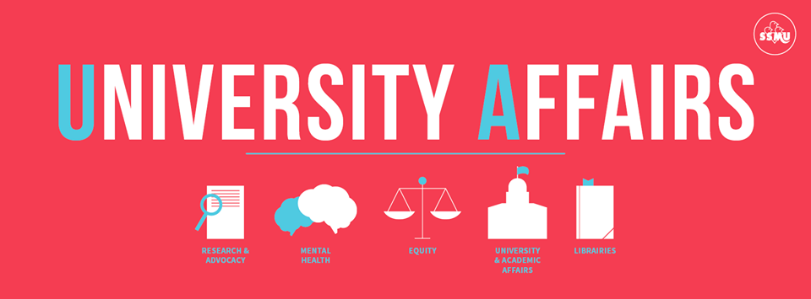
Like the SSMU University Affairs page on Facebook for important updates!

Joint Projects
- Senate
  - Met on Wednesday, October 21st
    - Open Discussion on “McGill’s International Strategy”
    - Follow-up on executive pay information & CAMSR
  - Joint Board-Senate Meeting this Tuesday, November 3rd (will report orally)
  - Next Senate meeting Wednesday, November 18th
    - Drafting questions around student mentorship, employment equity & possibly divestment
    - Hoping for updates on reviews around research ethics & misconduct
- Senate Caucus
  - Discussed pending Senate questions, institutional memory, student engagement, mid-term progress & goals
- Arts & Science
  - Alex attended BASiC Assembly October 13th; Erin will attend November 3rd
  - Institutionalizing Arts & Science Senator position:
    - SSMU VP UA & Internal Regulations Review Committee will look at Senator allocations process
  - Funding improvements for Arts Sci scholarships, admin & teaching resources
    - Waiting to hear back from Faculty of Science re: Arts Sci scholarships
    - Will speak to Provost about admin funding at November office hours
- Joint Board-Senate Meeting
  - Meeting on November 3rd to discuss designing a “Smart Campus for the 21st Century”

Alex Kpeglo-Hennessy

Senate
- Committee on Student Grievances
  - Hearing has been scheduled for the third week of November
- JBSCE Subcommittee on Queer Equity
  - Attended the annual LGBTQ Homecoming event, Return to the Rainbow
  - Next meeting is November 18th
- Advisory Committee on the Charter for Student Rights
  - SQ
- Subcommittee of the APC on Teaching and Learning
  - The upcoming meeting on November 19th was cancelled
  - Next meeting is January 12th
- Ad-Hoc Committee to Review the Charter on Student Rights
  - Waiting to hear back about the first meeting of this committee
- Advisory Committee on the Possible Reappointment of the Dean of Students
  - Waiting to hear back about the first meeting of this committee
- Committee on Student Services
  - Next meeting is on November 12th

AUS

- Committee on Student Affairs
  - Next meeting will be November 11th
- Accountability Committee
  - SQ

SSMU

- Student Society Programming Network
  - SQ
- “Know Your Rights” Working Group
  - Attended a meeting on October 30th

Erin Sobat

Senate
- Academic Policy Committee (APC)
  - Next meeting Thursday, October 29th meeting cancelled; next meeting Thursday, November 19th
- Enrolment and Student Affairs Advisory Committee (ESAAC)
  - Next meeting this Tuesday, November 3rd (will report orally)
  - Hoping to move forward with Fall Reading Break proposal & Student Assessment Policy revisions
- Committee on Student Services (CSS)
  - Next meeting Thursday, November 12th
  - Will be pushing for transparency in upcoming budget planning process
  - Internal Unit Review also happening later this month
- Principal’s Task Force on the Royal Victoria Hospital Site
  - Met Friday, October 30th
  - Developing self-assessment questions for McGill units & services who could see themselves moving to the RVH site if acquired
  - Next meeting Monday, November 9th
- Senior Director of Student Services Search Committee
  - Status quo pending further discussions with the Deputy Provost (see joint statement released by student associations: http://ow.ly/SRqO9)

SSMU
- SSMU Council
  - Met Thursday, October 15th
  - Approved CKUT & Safety Network fee Referenda, Yearbook fee & student-run cooperative plebiscites, Climate Change Policy, statement on satire, Law Library exam compromise
  - Next meeting Thursday, November 5th
- SSMU Internal Regulations Review Committee (IRRC)
  - Met Thursday, October 29th to starting reviewing President IRs (~80pp)
  - Next meeting this Wednesday, November 4th to review remainder
  - Winter term projects: Constitutional amendments & Internal Regulations for remaining portfolios (Internal, Clubs & Services, University Affairs)
- SSMU Nominating Committee
  - Missed meeting Wednesday, October 21st for AUS Council
  - Held e-vote on DEO candidate; reporting to SSMU Council November 5th
- “Know Your Rights” Working Group
  - Met Friday, October 30th; discussed project background, goals & tasks
  - Goal to launch Student Rights website for January promotional campaign
  - Next meeting TBD (week of November 8th)
- University Affairs Committee
  - Responsible for overseeing research & advocacy priorities of UA portfolio, including advising on SSMU MoA negotiations
  - Currently finalizing membership (first meeting TBD very soon)

AUS
- Memorandum of Agreement Working Group
  - President & VP Finance met with DPSLL on October 23rd
  - Currently proposal would allow SNAX to sell sandwiches, however negotiations will continue around university’s inspection authority
- Ad-Hoc Human Resources Committee
  - Now co-chairing this committee with the Secretary General
  - First meeting TBD (later this week or early next)
- Dean of Arts Search Committee
  - Met on Wednesday, October 7th to shortlist candidate for Dec interviews
  - Next meeting Tuesday, November 17th to review interview questions
- Faculty of Arts Meetings
  - Met Tuesday, October 27th
  - Passed motion to integrate Religious Studies as a School; Interim Dean of Arts announced $200 000 cut to administrative & support staff budget; review of the Arts administrative hubs to occur later this month
  - Next meeting Tuesday, November 24th
- Curriculum Committee
  - Met on Monday, October 19th
  - Approved program & course changes in German, Islamic Studies, Classics & Institute for Gender & Feminist Studies
  - Next meeting Monday, November 16th
- Humanities & Social Sciences Library Advisory Committee (HSSLAC)
  - Missed first meeting Friday, October 23rd
  - Next meeting Thursday, December 10th
- Other Projects
  - Will be assisting KANATA & Indigenous Alliance McGill in creating an Indigenous Studies Students’ Association
  - Advising on review of departmental constitutions & GA procedures
  - Contributing to discussions around VP Finance selection & training

Respectfully Submitted,

Alex Kpeglo-Hennessy, Arts Senator
Erin Sobat, Arts Senator

