Report of the AUS VP Academic – November 18, 2014
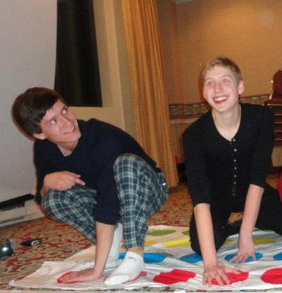
I apologize for the rather short report, I broke my wrist last week and can hardly type anymore… enjoy this beautiful picture of Senator Sobat and President Greenspon.

6th Annual Faculty of Arts Undergraduate Research Event
I am looking for a few volunteers for this event, which will be held TBD. This is a great opportunity to learn about Arts undergraduate research and to build relationships with Professors and the Arts Internship Office. If you would like to help out (particularly if you have McGill Server Training), please let me know.

AUS-Library Partnership Committee
We are meeting on Friday the 20th to go over some of the preliminary ideas that were brainstormed over the past couple of weeks. There is a very important survey on this week’s listserv that is also very short, so please take the time to fill it out! Our next meeting will probably be the week before finals.

APPRS + Undergraduate thesis retreat
I am meeting with the Arts Peer-to-Peer Research Symposium coordinators later this week to start planning out the event, which will be held in February.
I’m also looking for volunteers to help me plan the first ever arts undergraduate thesis retreat! It will probably be held sometime mid March but I need all the help I can get to figure things out logistically.

New advising initiative: S!MVO
John Nnmachi and I met with Nellie from OASIS and she is on board with the idea, provided that we meet with different departments to write down all the requirements specific to all departments. I am currently putting together a team of students to go meet with various departments and get all of that info down.

Committee on Student Affairs
We met last Wednesday the 11th. We discussed issues such as Mental Health, Faculty involvement in addressing mental health and information overload issues, the early alert system.

Curriculum Committee
I had to miss the meeting last Monday the 16th because of an appointment with OSD.

Faculty of Arts Meeting
Next meeting in Tuesday 24th, will report next council.

Respectfully submitted,

Gabriel Gilling

