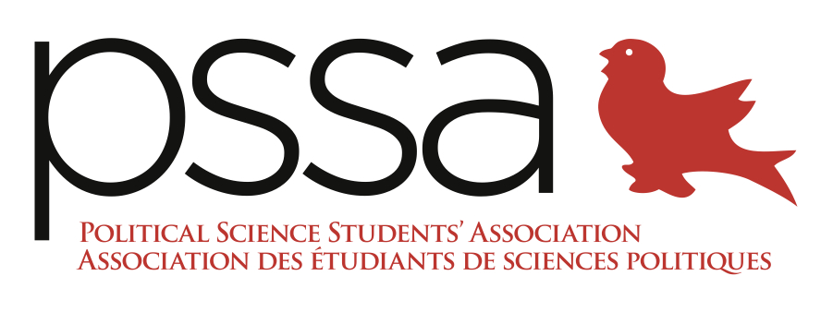

The Political Science Students’ Association Report to the AUS Council
Friday, February 5th, 2016

President: Richad Hirani
- Contacted MyInvolvement for the PSSA to be linked to and permanently featured on the website. PSSA is now featured and hours are being added to transcripts.
- Applied for SSMU Winter 2016 Campus Life Fund, Club Fund
- Looking into AUS Journal Fund and Supplementary Funding for MJPS Launch and Professor Awards

VP Academic: Jesse Shuster-Leibner
- Launched the NTC program for POLI 227. NTCs are comprehensive, supplemental notes written by note-takers in the assigned class for students.
  - Hired proofreaders, editors, and notetakers
  - Selling NTC packages:
    - $45 cost during office hours
- Research Brunch – March 15 (11AM – 1PM) in Wendy Patrick
  - Budget: ~$200

VP Events: Tofunmi Odugbemi
- In the process of booking and planning the Ottawa Trip (Question Period, Byward Market, skating on Rideau Canal, War Museum, etc.)
  - Date: March 11th
  - Poster has been made
  - Booked Question Period (past noon)
  - Bus quote: ~$850 including tip, looking into insurance
- In the process of planning Interdepartmental Mixer – February 18 confirmed
  - Contacted departments to collaborate. So far, only ESA has confirmed.
  - Poster has been made
  - Finalizing master-plan contract with Thomson House
  - Finalizing tickets (price, design)
  - Confirmed jazz band
- In the process of planning the McGill Journal of Political Studies Launch and Professor Awards at Thomson House or Faculty Club
- Coordinating Samosa Sale (February 10) and Pastry Sale (February 17)
- Planning Charity Event with McGill War Child – March 23, 24, 30, 31
  - Featuring ex-child soldier, Emmanuel Jal (collaborated with Nelly Furtado and starred in movie with Reese Witherspoon)
  - $1500 fee, PSSA thinking of pitching!
- Booked Samosa Sale on March 30th

VP Internal: Stephen Bateman
- Peer Tutoring initiative underway
- Launched event with 1968 President of the regarding 1960s McGill protests feat. Professor Waller
  - Date of event: February 8st in Arts W-160
  - Showing different clips and videos of the protest
  - Contacting Professors Waller and Schultz to attend

VP External: Jonathan Turlione
- JDSP complete!
- Continuing communications with Concordia PSSA for Debate/4 à 7 events (February 8th and March 18th)
  - February 8 conflicts with PSSA President event, so postponing
- AUS Council Motions introduced at weekly meeting and voted upon

VP Finance: Roland Barlier
- Updating budget according to new events for the Winter 2016 semester
  - Mirza still counting Samosa Sale revenue
  - Acquiring after contacting Roland
- Furniture: free book case and coffee table
  - Ordering for PSSA through Pina then reimbursing the department
- AUIF Money: Potentially $500
- Journal funding: reapplying for the fund with binding
- Creating plan to sell remaining Political Science sweaters by the end of the semester

VP Communications: Ida Mahmoudi
- Asked by Professor Pelc to introduce United Nations Secretary General Ban Ki Moon at McGill event next Friday. Potentially providing symbolic token.
- Transcribing February 4th “Law, Politics, and Space” talk with Dr. Cassandra Steer. Sending for French translation afterwards.
  - Posted slides and presentation on Facebook event.
- Made quick website changes; over 1000 views on website this month!
- Working on archiving all minutes and events to be posted on Accessibility Page
- Working on transcribing past events for Accessibility portfolio
- Sent weekly listserv updating students on all events and initiatives
- Developing marketing plans for: Ottawa Trip; Interdepartmental Mixer; Journal Launch
- Contacting new professors for Professor of the Month initiative (newly institutionalized)
  - Interview with Pelc complete. Interviewing Proksch next Thursday

