Report of the VP Academic - February 24, 2016

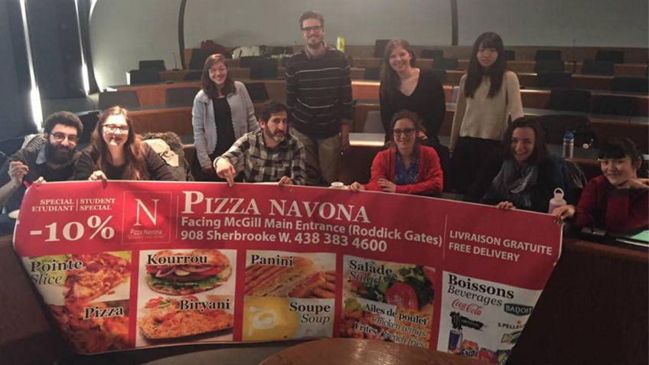
Thanks to those who presented/attended the APPRS! Here’s a picture of some of our participants.
It’s midterm season so things have been going a bit slow, good luck everyone with all your work!

Arts Student Employment Fund:
We have received some exciting applications from a diversity of units across campus. The ASEF Committee will be meeting to review these on Friday, February 26th, and I will be bringing their decisions to AUS Council for final approval on March 9th.

Academic Affairs Committee
The database for S!MVO is slowly being completed! Thank you to all the Departmental VP Academics who helped and sent their program requirements. The AAC will be meeting after break to go over what we have compiled and to gather the remaining information. If your department has not send me their program requirements, please do so ASAP!

Feedback on ASCs
Included in the listserv. Please fill out the following form in order to help us understand how this service has impacted you as a student!

Valedictorian & Teaching Awards Committee
Meeting dates set for mid March. The Dean will be attending. Again please refer to the listserv for the nomination packages/application forms.
For the Valedictorian package, the date to apply is Sunday March 13th at 5pm.

Departmental Academic Roundtable:
Scheduled for the 2nd week after reading week. Discussions points TBA.

Misc:
- VP Finance and I will meet with the AIO to discuss financing
- Met with CBRC to outline the AIO Advisory Committee bylaws
- Couldn’t attend the McGill Academic Roundtable on Tuesday 16th so I will meet with SSMU VP UA sometime after break to catch up
- Met with Archiving commissioner to write bylaws for Archiving, will meet with CBRC after break to validate them for council approval
- Faculty committees are spread through March and April. Will report on them closer to the meeting dates.
- Gab’s globe has been updated.

Respectfully submitted,

Gabriel – AUS VP Academic

