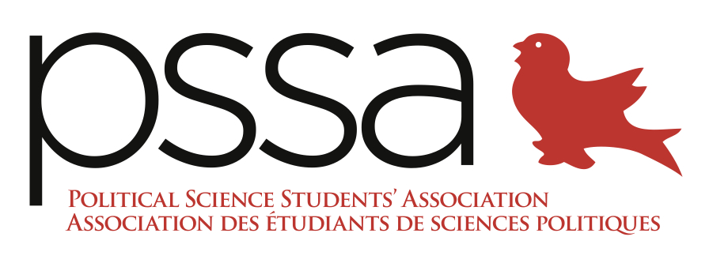

The Political Science Students’ Association Report to the AUS Council
Friday, March 18th, 2016

General Update: Two executives (Jesse and Ida) received the Scarlet Key Award because of their contributions to the PSSA and were awarded with 12 others at the March 19th Pinning ceremony.

President: Richad Hirani
- Provided scheduling and updates for upcoming events and funding
- Finalized Faculty Club venue for April 7th MJPS Launch and Prof Awards
- Finalizing expense report for Interdepartmental Mixer from February 18th
- Held reconciliatory meeting with the VP Events for Ottawa Trip mishaps and feedback with Ida
- Delegated AUS Awards applications to members

VP Academic: Jesse Shuster-Leibner
- Added all edits to final academic policy, sent to Professor Oxhorn (Meeting TBD)
- TA Handbook final draft ready, sent to Oxhorn to disseminate to TAs

VP Events: Tofunmi Odugbemi
- Launched “Nothing But Nets” Charity fundraiser event, to be held on March 24
  - Solidified theme, organization (Against Malaria Foundation), prices
  - Creating coat check schedule for Events Portfolio
    - 8 shifts filled (1 hour shifts, 4 people per shift)
  - Poster up; event up
  - Decided on no DJ

VP Internal: Stephen Bateman
- Cancelled Thomson House contract for April 6th because of change to Faculty Club

VP External: Jonathan Turlione
- Continuing communications with Concordia PSSA for Debate/4 à 7 event. Talking with Nora (PSSA VP External of Concordia) for another collaboration.
- Getting pictures from previous Feb 11th debate
- AUS Council updates to the PSSA Executive

VP Finance: Roland Barlier
- Balances same as last week
- Haven’t received 1st instalment from Campus Life Fund. Need sums to come in before the 7th of April because we have enough cash for the Faculty Club but not the Journal
  - Sending followup to Dayna Austin (Funding Commissioner)
- Getting new cashbox from Mirza
- Reimbursing one member for purchases

VP Communications: Ida Mahmoudi
- Looking into Calendar estimates to create Prof of the Month calendar according to different months. Pitching calendar to professors and students.
- Developed and launched Student of the Week series
- Contacted TVM and had them record the March 15 Research Brunch
  - They will also be attending and filming the Journal Launch and Prof Awards
- Executed video for Research Brunch
- Developing the design for the Prof Awards certificates
- New Professors of the Month: Professors Baccini and Johnson
  - Baccini Interview – Tuesday 5pm (complete and posted)
  - Johnson Interview – 21st of March at 230PM
- Updated website with the PSSA Executive Nomination Kit. Sent all applications to Election AUS and filtered through all student signatures.
- Sent weekly listserv updating students on all events and initiatives
- Developing marketing plan for Journal Launch
  - Launched the PSSA Awards poster, created by Portfolio member Brayden Culligan
  - Created nomination form for students to vote on Professor Teaching awards and TA awards
- To date, increased audience by 480% on Facebook (new analytics update)

