Office: (514) 398-1993
Fax: (514) 398-4431
http://www.ausmcgill.com
Arts Undergraduate Society of McGill University
855 Sherbrooke Street West
Leacock B-12
Montreal, Quebec H3A 2T7

Report of the Arts Representatives, AUS Council
Wednesday, September 21st, 2016

I. Introductions

Isabella Anderson
Hey everyone, I’m Isabella and I’ll be one of your three Arts Reps for the 2016-2017 school year! I’m a U2 Political Science major with a double minor in International Development and Communication Studies. This year I hope to increase outreach and advocacy for Arts students’ needs while also promoting accountability within the AUS and SSMU to ensure the Arts faculty feels fully represented in executive decisions! Feel free to reach out via email (artsrep3@ssmu.mcgill.ca) if you need anything!

Maria Thomas
Hi everyone!
I'm Maria! I'm a U1 student with a double major in sociology and international development! I'm honored to be one of your arts reps to SSMU! This year, I'm really focused on trying to increase mental health services at McGill and outreach endeavors to understand each student issue! Thanks! Please feel free to email me etc. (artsrep4@ssmu.mcgill.ca) if you need anything!!

Igor Sadikov
Hi! I'm Igor and one of your reps to SSMU for the year. I'm a U4 Mathematics & Political Science student and I really want to make AUS Council a core place for consultation on issues coming up at SSMU. My main areas of interest are SSMU governance reform, political mobilization, and student rights advocacy. Hit me up if you want to chat about SSMU (or anything else), during office hours or by email at artsrep2@ssmu.mcgill.ca!

II. Retreats!
- SSMU Retreat
We had a great time getting to know all about SSMU and the plans for 2016-2017 over the weekend of September 9–11. We also had the opportunity to meet many of this year’s Councilors from other faculties.
- AUS Retreat
This past weekend (September 16–18) we spent time with the AUS Executive Committee getting to know each other better and getting some work done for the AUS!

III. SSMU Council
We took part in our first SSMU Legislative Council meeting on Thursday, September 15. We discussed the Alternative and Equitable Governance report that was compiled over the summer, and this year there will be a committee devoted to looking at ways to best implement the recommendations made by this report. In addition, we passed a number of procedural motions and repealed the Accountable Leadership Policy.
All other Council documents, including motions and Executive reports, can be found on the SSMU website.

IV. Committees
- AUS
Isabella – Faculty of Arts Committee; Committee on Student Affairs
Maria – Faculty of Arts Committee
Igor – Curriculum Committee

- SSMU
Isabella – Steering Committee
Maria – Mental Health Committee
Igor – Steering Committee; Ad-Hoc Provincial Representation Committee

V. Current Adventures
- Igor – Began work on collaboration between Divest McGill and other campaigns to provide an accessible interface to McGill's investments. More details to come.
- Pinning down our Office Hours (come visit us!)
- Preparing for our first Committee meetings
- Planning our first outreach initiatives

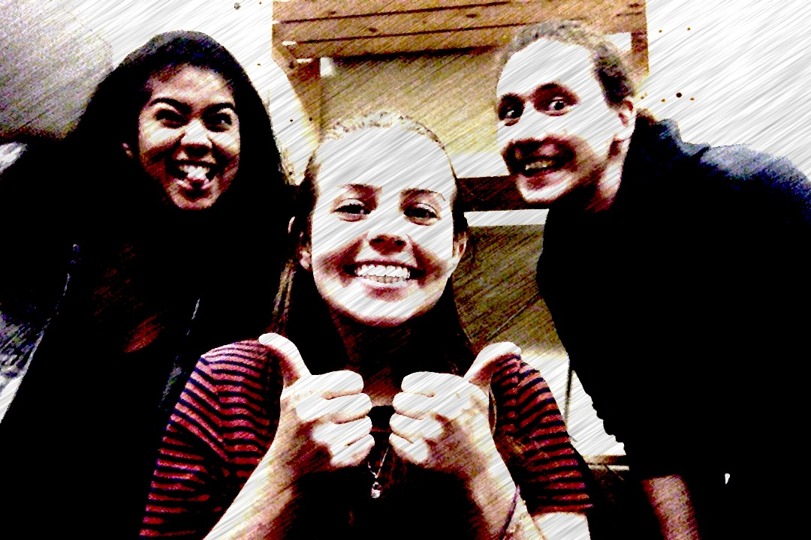

Respectfully Submitted,

Isabella Anderson
Maria Thomas
Igor Sadikov
Arts Representatives to SSMU

