Office: (514) 398-1993
Fax: (514) 398-4431
http://www.ausmcgill.com
Arts Undergraduate Society of McGill University
855 Sherbrooke Street West
Leacock B-12
Montreal, Quebec H3A 2T7

Report of the Vice-President Communications, AUS Council Wednesday, October 5th, 2016

I. Committee Updates
- Fine Arts Council
Counsellor Sybil Chen will be sitting on FAC. In the first two meetings the team has talked workshops, Nuit Blanche, and budget.

In previous years, the FAC received $10 000 from the AUIF – not sure whether or not things are still the same. In the case that we are not receiving AUIF funding, I reviewing my portfolios budget.

- Francophone Commission
Our Graphic Designer will be sending us a couple of mock ups for the Francophone Commission logo. Last week the commissioners, Garima and Felix, took their group of a little field trip to CinémaduParc on Avenue du Parc; they watched a francophone film with their group.

- Marketing Committee
The committee has been hired:
- Michaella Anthony
- Khyati Ghandi
- Milana Hiebert
- Anna St-Clair
- Vittoria Trolio
Counsellors Maria Rizzuto, Idil Uner, and Madeleine Cruickshank will sit on the committee.

The committee will meet on a monthly basis; however, this will change depending on events needing promotions and projects in the works at the time. The committee is still discussing it, but we will probably meet on Tuesdays at 7pm.

II. Graphic Designer
Brayden has worked on a design for a sweater for the AUS exec.
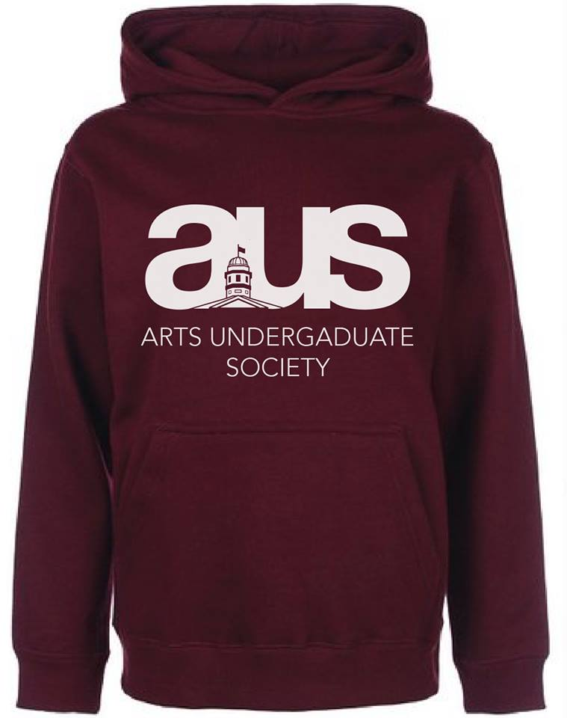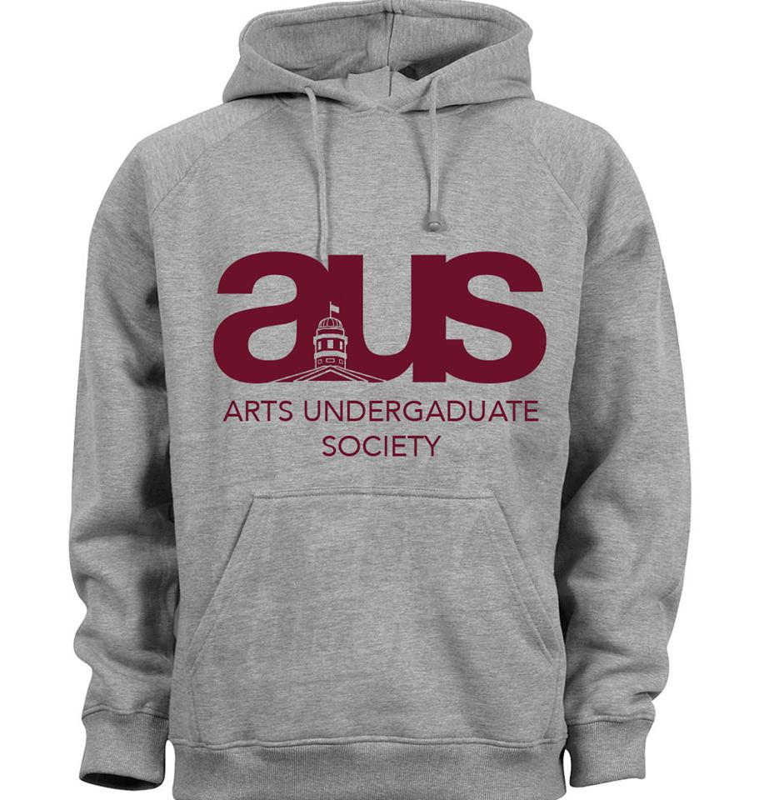

III. AUS Media Team
Naomi, AUS photographer, took the AUS exec headshots this past Monday. Also, Victoria worked on FEARC headshots with Kira and took photos for the AUSec Wine and Cheese on Tuesday.

IV. AUS Free Printing Services
Lawrence, the technology coordinator, has been in touch with the CTF (Computer Task Force), McGill IT, and Uprint. They will get back to us with pricing and we will see what we can do from there.

Respectfully Submitted,

Chanèle Couture De-Graft
Vice President Communications

