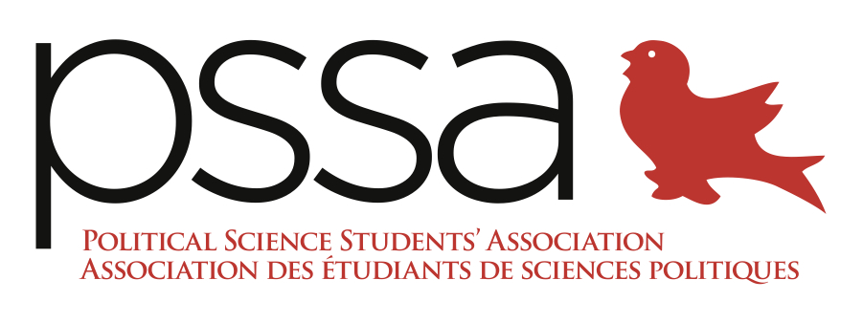

Report of the Political Science Students’ Association, AUS Council February 22nd, 2017

President
- Sweaters will hopefully be ready by next week
- Attended Presidential Roundtable, discussed that departmental elections should be made more accessible
- NTCs are now available, system is set up

VP Events
- The Political Science Games is now open for sign up, event is life. The Against Malaria Foundation has been chosen as our charity
- Organized Midterm Mixer with Econ and Comp Sci
- Ottawa Trip had to be canceled
- Been integral in organizing referendum

VP Internal
- Secured rooms and photographers

VP Finance
- Updated budget
- Is waiting on AUS allocation

VP Academic
- Data Club sold out, held their first session and have scheduled the rest
- Planning second semester Research Brunch
- Working out financing for the JDSP

VP Communications
- Looking to hire a web designer to figure out the website
- Working on Professor of the Month

VP External
- JDSP is working on getting receipts to give to the AUS to get their funding
- Gotten sponsorships to use as prizes for the Poli Sci Games
- Had arranged to meet with an MP in Ottawa – will now be speaking over Skype instead
- Been working on Motion to Amend the Equity Policy By-Laws

