Office: (514) 398-1993
Fax: (514) 398-4431
http://www.ausmcgill.com
Arts Undergraduate Society of McGill University
855 Sherbrooke Street West
Leacock B-12
Montreal, Quebec H3A 2T7

Report of the Vice-President Communications, AUS Council February 22nd, 2017

I. Committee Updates
- Fine Arts Council
- Poster done! Photographers locked in! Videographer locked in!
- See you March 23rd 2017
- Last workshop (music) taking place at nuit blanche
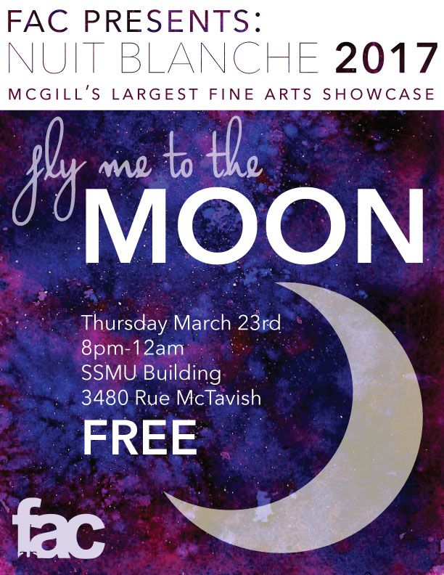

- Francophone Commission
- Collab event with le délit and French Students Club – March 15th 2017

- Cabane à sucre mobile – application approved by campus space and planning + parking
- ProfTalk: En français

- Marketing Committee
- 2 surprise projects – confirmed with groups keep an eye out
  - Nuit Blanche promo

- AUS Media Team
- Photographers locked in for Nuit Blanche and GradBall

Respectfully Submitted,

Chanèle Couture De-Graft
Vice President Communications

