Office: (514) 398-1993
Fax: (514) 398-4431
http://www.ausmcgill.com
Arts Undergraduate Society of McGill University
855 Sherbrooke Street West
Leacock B-12
Montreal, Quebec H3A 2T7

Report of the Vice-President Communications, AUS Council March 22nd, 2017

I. Committee Updates
- Fine Arts Council
- NUIT BLANCHE TOMORROW!!!!!!
- MusicRep workshop is taking place here (that’s all the workshops for the year)
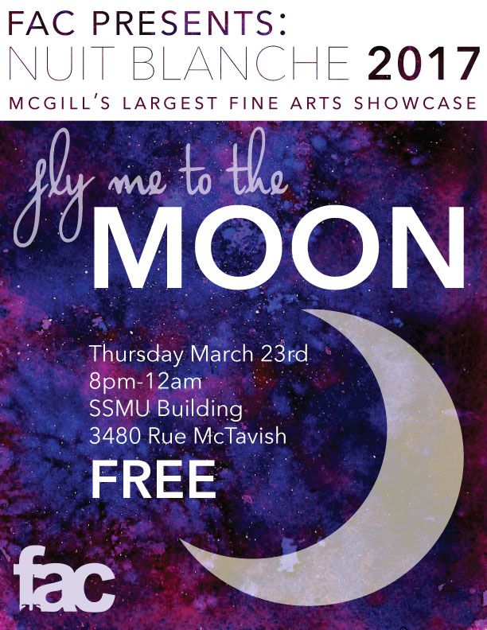

- Francophone Commission
FRANCO FÊTE
- Rap Battle event was cancelled because it happened the day of the snowday. We are seeing if we can have the event in SSMU (probably Gert’s). Stay tuned!
- Cabane à sucre mobile
  - Success on campus! From videos to people cheering, everyone was extremely excited to see an authentic Quebecois initiative on campus!
- ProfTalk: En français
  - The prof thought the event was fun and interesting! The attendance was better than I thought, especially given the weather! First ProfTalk in French, I think there’s a lot of potential for more.
- French conversation circles
  - Relaxed setting, tonight they are supposed to go to Gert’s, last week they read traditional Quebecois fables/stories

- Marketing Committee
  - Urban Groove did a FlashMob for Nuit Blanche promo! Successful – we had a big audience right after a LEA 132 class!

- AUS Media Team
- GradBall picture are ready to be uploaded! The video is coming soon!

- Transition
- Met with Maria to discuss the upcoming hiring period and how we will proceed.

Respectfully Submitted,

Chanèle Couture De-Graft
Vice President Communications

