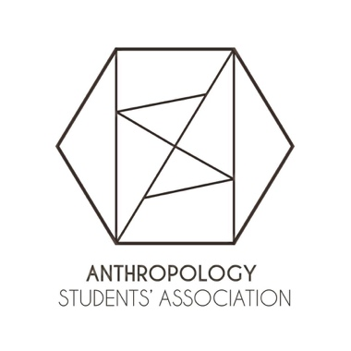
Report of the ASA Executive Board, AUS Council February 27, 2019.

Overview
We have all been heavily involved in the hiring committee in these last few weeks and have facilitated private meeting between anthropology undergrads and potential hires.

President Mayra Castellanos
- Planned and facilitated meetings every week in.

VP Events Isabella Daniele and Khando Langri
- Held TA Tuesday events, in which undergrads interact with their anthropology TAs and discuss graduate school and research.
- Held a movie screening.
- Are coordinating and planning the events for this semester.

VP Academic Chloe Wong-Mersereau
- Has prepared a form to order a second batch of Anthropology sweaters due to popular demand.

VP Internal Jordanna Gisser
- Sat in on faculty meetings discussing our voice on the new hire.
- Is in the process of going over compatibility and repetition amongst classes and their syllabus and questioning if the degree and its requirements should be restructured.

VP Communications Sarah Nelson
- Consistently send out the listserv email every week.
- Is keeping track of ASA events and updates in order to post it on our Facebook page.

VP External Ella Martindale
- Helped Chloe with sweater orders.
- Providing feedback on other people’s endeavours at this time.
- Is organizing the forms for elections.

VP Finance Damian Arteca
- Updated the budget.
- Is helping VP publications and VP events with grant applications for our journal launch/movie showcase event.
- Held two Samosa sales.

VP Publications Camille Ballick
- Has begun editing the accepted pieces for Fields/Terrain alongside the editorial team.

