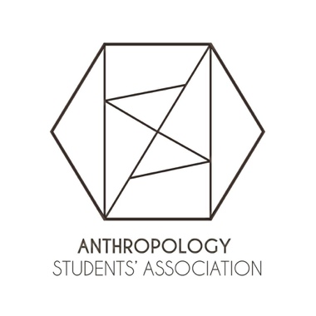
Report of the ASA Executive Board, AUS Council February 27, 2019.

Overview
Our main task as an association has been our continued involvement in the hiring committee in these last few weeks. We have facilitated private meeting between anthropology undergrads and potential hires and will continue to do so for the next two potential hires.

President Mayra Castellanos
- Planned and facilitated meetings every week notably by ensuring that all members are aware of each other’s tasks and setting an agenda.

VP Events Isabella Daniele and Khando Langri
- Held TA Tuesday events, in which undergrads interact with their anthropology TAs and discuss graduate school and research.
- Are planning the Anthropology Mix Media event which will serve as journal launch and showcase for student made sensory ethnographic films

VP Academic Chloe Wong-Mersereau
- Has submitted a second order for Anthropology sweaters.

VP Internal Jordanna Gisser
- Continues to work alongside the anthropology department in regards to the Indigenous hire process.
- Is in the process of going over compatibility and repetition amongst classes and their syllabus and questioning if the degree and its requirements should be restructured.

VP Communications Sarah Nelson
- Consistently send out the listserv email every week.
- Is keeping track of ASA events and updates in order to post it on our Facebook page.

VP External Ella Martindale
- Continues to work on the Indigenous hiring process.
- Helped organize the forms for elections for next year’s ASA.

VP Finance Damian Arteca
- Updated the budget.
- Held two Samosa sales.

VP Publications Camille Ballick
- Is putting the last touches on the journal and will sound send the finalized copy to be printed. Additionally, she is helping plan the Mix Media event.

