Office: (514) 398-1993
Fax: (514) 398-4431
http://www.ausmcgill.com
Arts Undergraduate Society of McGill University
855 Sherbrooke Street West
Leacock B-12
Montreal, Quebec H3A 2T7

MIRA Motion to Approve A New Logo

Whereas, The MIRA believes that our old logo would benefit from an update after 5+ years,

Whereas, The MIRA needs to use the official logo for printing promotional material and for advertising important events,

Be it Resolved, that the AUS Legislative Council approve MIRA’s decision to change our official logo from our old one, which logos are properly labeled below:

Old Logo:
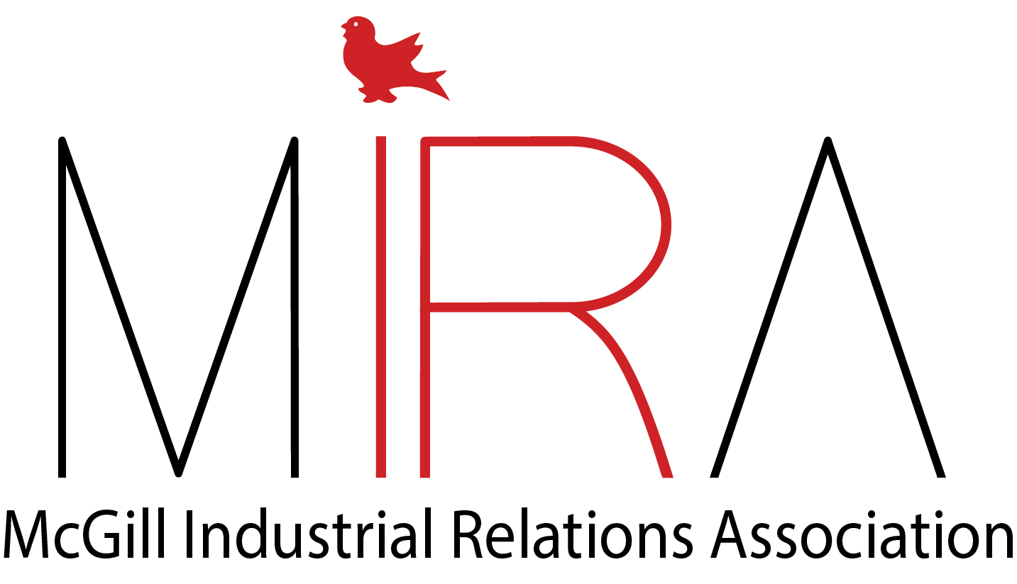
New Logo:

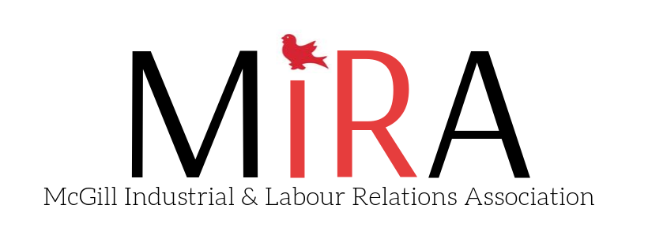

Moved by,
Elisabeth Levin
VP External, MIRA

Seconded by
Ananya Nair
AUS VP Academic

