Office: (514) 398-1993
Fax: (514) 398-4431
http://www.ausmcgill.com
Arts Undergraduate Society of McGill University
855 Sherbrooke Street West
Leacock B-12
Montreal, Quebec H3A 2T7

Whereas, the HSA is unaware of any official logo which has been approved by this body that has been commonly used at any point in the past few years, yet still requires both an official logo for branding purposes and an official header for usage on official documents,

Whereas, the heraldic martlet adds a unique and historical flair to our HSA departmental logo,

Be it Resolved, that the AUS Legislative Council approve HSA's decision to adopt our official logo and header as the following:

Logo:
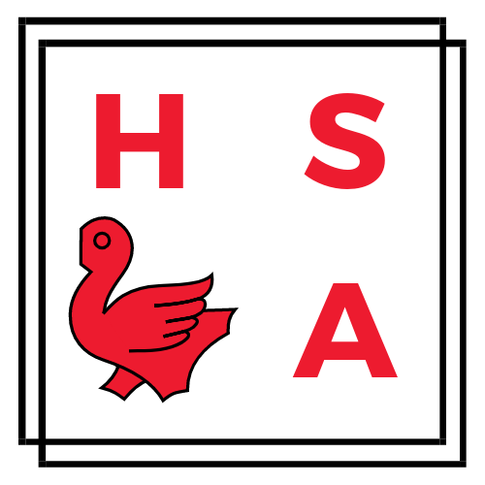

Header:
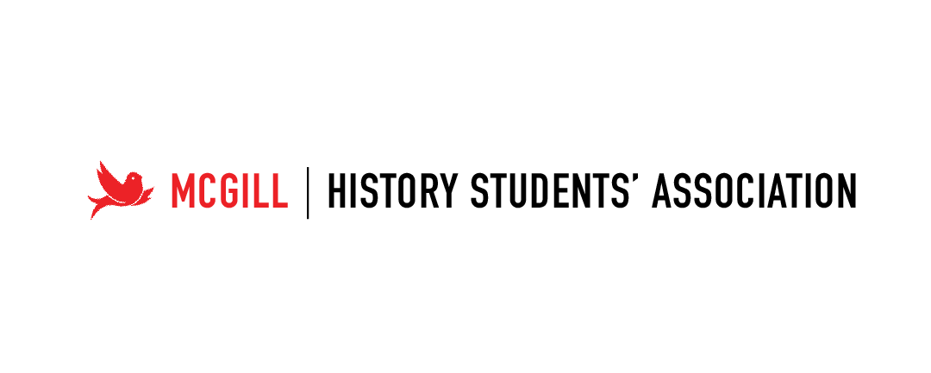
Moved by,
Dalton Liggett,
VP External HSA

