Office: (514) 398-1993
Fax: (514) 398-4431
http://www.ausmcgill.com
Arts Undergraduate Society of McGill University
855 Sherbrooke Street West
Leacock B-12
Montreal, Quebec H3A 2T7

Whereas, the AHCSSA has been using the same logo for many years

Whereas, we want to revamp the department in honor of a new year and new executive who have brought new ideas!

Be it Resolved, that the AUS Legislative Council approve AHCSSA’s decision to adopt our official logo and header as the following:

Logo (Old)
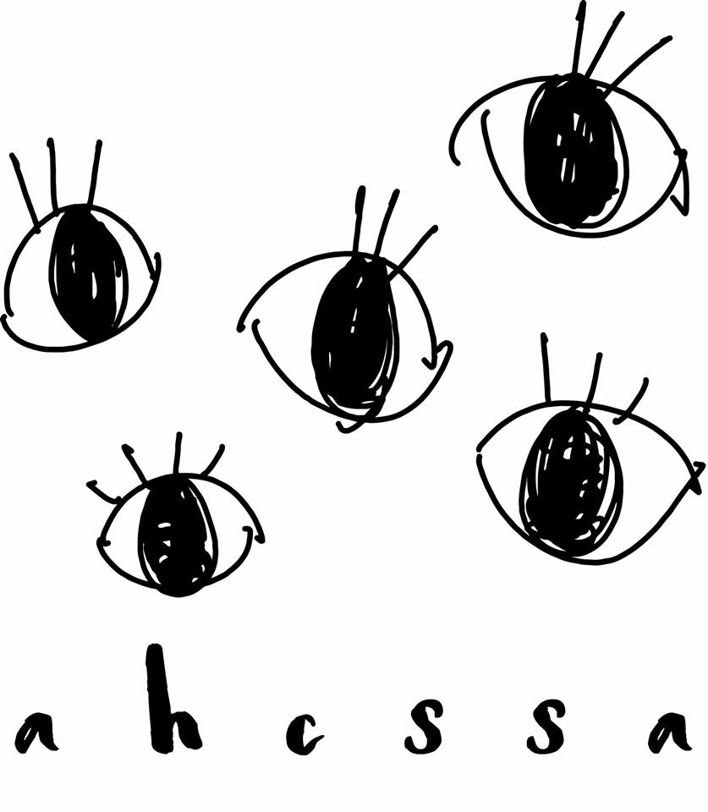

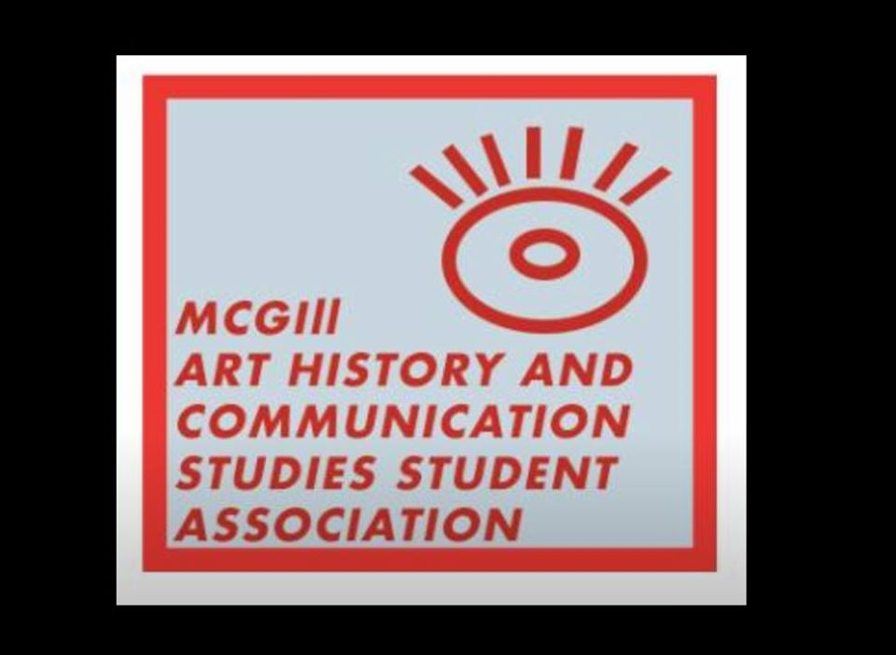Logo (New)

Moved by,
Ariana Kaye, AHCSSA President
Brent Jamsa, CSAUS VP External

