Office: (514) 398-1993
Fax: (514) 398-4431
http://www.ausmcgill.com
Arts Undergraduate Society of McGill University
855 Sherbrooke Street West
Leacock B-12
Montreal, Quebec H3A 2T7

Motion to Ratify a New Logo for the Philosophy Students’ Association (PSA)

Whereas, the PSA Coordinating Committee has widely recognized a need for a new logo for as long as I have been a part of it, as it seems the closest thing we have recently had is an austere portrait of Hegel;

Whereas, submissions were called for to determine potential logo candidates;

Whereas, a poll of the PSA’s membership was conducted in the membership’s closed Facebook group to determine the membership’s preferred candidate;

Whereas, the hand-drawn model for the logo originally submitted has been digitally rendered by a graphic design consultant, shown at the bottom of the page;

Whereas, the new logo chosen by the membership abides by all logo conventions;

Be it resolved that the PSA’s new official logo will be the same image as in the bottom but in a higher-resolution vector format (instead of a png).

Moved by,

Matt Gery
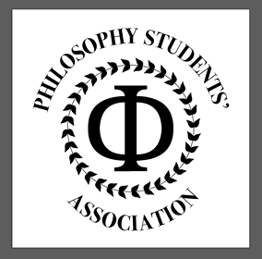
PSA External Affairs Coordinator

Seconded by, AUS VP Finance

