Arts Undergraduate Society of McGill University
855 Sherbrooke Street West Office: (514) 398-1993
Leacock B-12 Fax: (514) 398-4431
Montreal, Quebec H3A 2T7 http://www.ausmcgill.com
___________________________________________________________________________________________________________
Motion to Approve the Sociology Student Association’s New Logo

Whereas, The SSA Council disliked the previous logo, which we deemed too generic, and wanted to put forward a more recognizable one,

Whereas, SSA needs to use a logo for social media, advertising, documents, and other events,

Be it Resolved, that the AUS Legislative Council approve SSA’s decision to change our official logo from our old design to this new design, which are displayed below:

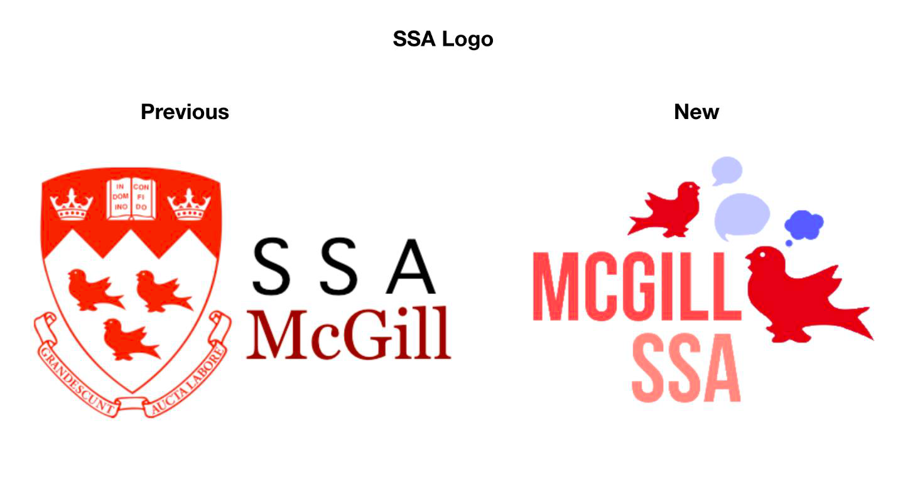

Moved by,
Samad Fagbohun
SSA VP External

