Office: (514) 398-1993
Fax: (514) 398-4431
http://www.ausmcgill.com
Arts Undergraduate Society of McGill University
855 Sherbrooke Street West
Leacock B-12
Montreal, Quebec H3A 2T7

CSA Motion to Approve a New Logo

Whereas The CSA’s current logo does not conform to the rules currently indicated in the MOA,

Whereas The CSA believes that our old logo is outdated and no longer representative of our department,

Whereas The CSA needs to use our logo in order to print pamphlets for official lectures and other important events,

Be it Resolved that the AUS Legislative Council approve the CSA’s decision to change our official logo to the following image:

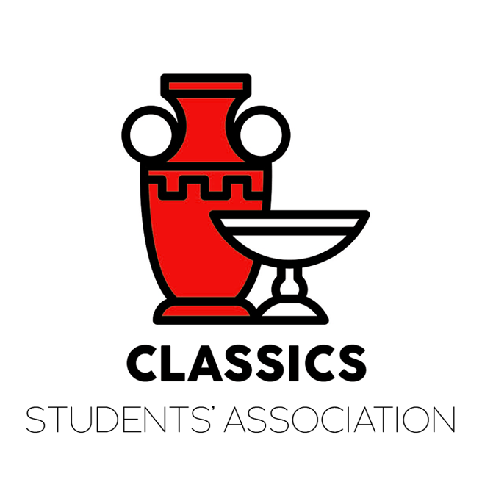

Moved By
Sara Merker
VP External, CSA

