MOTION TO AMEND THE INTERFACULTY IRP

Whereas, the AUS Legislative Council ratified the interfaculty IRP on October 30th, 2019;

Whereas, the motion to ratify the policy succeeded on the condition the VP Social would continue working on it and make necessary amendments to address councillors and constituents’ concerns and suggestions;

Whereas, these concerns have been taken into account and the following edits have been made to the IRP since its initial ratification:

- TO ARTICLE 5.1 “FACULTY COMMITTEE”:
  - Originally stated as: “Each Faculty Committee, and the GSVP Committee, shall be an impartial body and shall not conduct its activities or render its decisions in a biased manner. Decisions and recommendations made by the Faculty Committee shall not be based on personal characteristics such as race, gender, sex, religion, sexual orientation, disability, etc. the whole as defined in Section 2 of Article 10 of the McGill Charter of Student Rights and as per the definition of Discrimination contained herein.
Amendment:
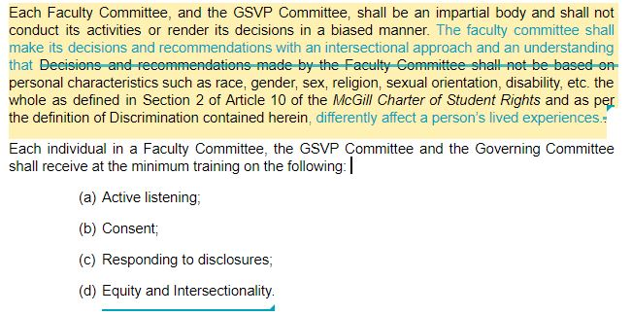
  - Originally stated as: “The use of a secured server or electronic files protected by a password;”
Amendment: “The use of a secured server or electronic files protected by a password, which will be provided by SSMU;”
  - Originally stated as: “In addition, the members of each Faculty Committee, of the GSVP Committee, and of the Governing Committee shall sign a confidentiality agreement at the beginning of their term. A violation of the obligations contained in the confidentiality agreement will constitute grounds for immediate removal from the Faculty Committee, GSVP Committee, or the Governing Committee, and further measures, as the case may be.”
Amendment: “In addition, the members of each Faculty Committee, of the GSVP Committee, and of the Governing Committee shall sign a confidentiality agreement at the beginning of their term. A violation of the obligations contained in the confidentiality agreement will constitute grounds for immediate removal from the Faculty Committee, GSVP Committee, or the Governing Committee, and other positions in the Student Association and SSMU.
- TO ARTICLE 5.2: “LODGING A COMPLAINT”:
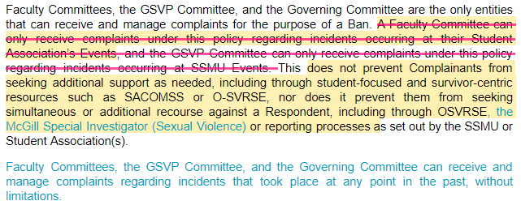
  - Originally stated as: “Faculty Committees, the GSVP Committee, and the Governing Committee are the only entities that can receive and manage complaints for the purpose of a Ban. A Faculty Committee can only receive complaints under this policy regarding incidents occurring at their Student Association’s Events, and the GSVP Committee can only receive complaints under this policy regarding incidents occurring at SSMU Events. This does not prevent Complainants from seeking additional support as needed, including through student-focused and survivor-centric resources such as SACOMSS or O-SVRSE, nor does it prevent them from seeking simultaneous or additional recourse against a Respondent, including through OSVRSE or reporting processes as set out by the SSMU or Student Association(s).”
Amendment:

- TO ARTICLE 5.3: “RECEIPT AND ANALYSIS OF A COMPLAINT”:
  - Originally stated as: “Following the receipt of a complaint, the Faculty Committee or GSVP Committee will, as part of the one-week period of analysing whether it is applicable to this Policy, ensure that all other factual elements (events, witnesses, dates, documents, etc.) which may corroborate the complaint are collected and compiled in writing.”
Amendment: Adding “This one-week period can be extended if unforeseen circumstances arise limiting the ability of the Faculty Committee, GSVP Committee or any involved party to evaluate the complaint.”
- TO ARTICLE 5.4: “INVESTIGATION”
  - Originally stated as: “For example, if there is a possibility the Complainant may have been harassed by a Person, appropriate action will be taken in that regard. The Investigator may, amongst other things: a) Prohibit the Respondent from communicating with the Complainant during the investigation process; b) Prohibit the Respondent to attend, participate or staff in any SSMU’s or the Student Associations’ Events in which the Complainant is involved;”
Amendment:
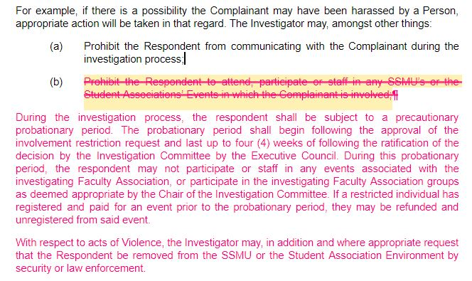
- TO ARTICLE 5.5: “INVESTIGATION OUTCOME”:
  - Originally stated as: If the Investigator, at two third majority of its members, comes to the conclusion that there has been no violation of this Policy, the Investigator, or his or her designate, will inform the Complainant and the Respondent in writing and will close the file. If, however, the Investigator, at two thirds majority of its members, believes there has been a violation of this Policy, the Investigator, or his or her designate, shall notify the Complainant and the Respondent of the result and of any corrective action taken. They will then submit the findings of the case and the actions taken to the chair of the Faculty Committee or GSVP Committee for permanent filing.”
Amendment:
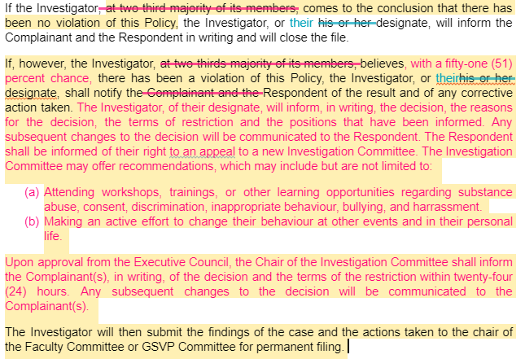
- TO ARTICLE 5.6: “CONSEQUENCES”:
  - Originally stated as: “The terms of the Ban shall include details regarding the restrictions, period of time in which the Ban is applied, the type of Events that will be restricted and that any violation of the terms of the Ban may be subject to further measures.”
Amendment: “The terms of the Ban shall include details regarding the restrictions, period of time in which the Ban is applied, the type of Events or roles that will be restricted and that any violation of the terms of the Ban may be subject to further measures.”
- TO ARTICLE 6: “CONFIDENTIALITY”:
  - Originally stated as:
“The SSMU and the Student Associations also recognize the concerned parties’ interest in maintaining the confidentiality of the information provided. As a result, information about complaints and incidents shall be kept confidential to the extent possible. Information obtained about an incident or complaint of Discrimination, Violence, Harassment or Improper Conduct, including identifying information about any Person involved, will not be disclosed unless disclosure is necessary to protect a Person, to investigate the complaint or incident, to take corrective action, including a Ban, or otherwise as required by law.
When a complaint has been lodged, the Complainant, the Respondent and any other concerned parties, are bound by a duty of confidentiality throughout the investigation and at all times thereafter and are strictly prohibited from disclosing the details of the complaint to anyone, except to the Investigator.
Anyone, including the Complainant, the Respondent or a witness, who violates the confidentiality of a complaint, will be in breach of this Policy which may result in disciplinary action, a Ban, or any other appropriate measure.”
Amendment:
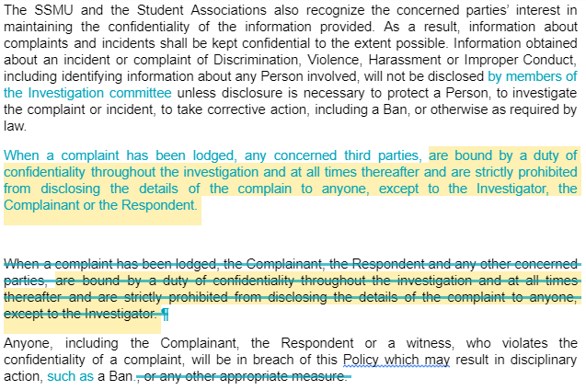
- TO ARTICLE 9: “APPEAL”:
Originally non-existent.
Amendment: Created Article 9, the appeal process.
“A respondent in an involvement restriction case may appeal the Investigation Committee’s decision within twenty (20) academic days of the notification stipulated in article 5.5.

The appeal process will be submitted to the Equity Commissioner(s) or the President of the investigating Faculty Association. The grounds for appeal must be specified. The Appeal Committee shall be chaired by the Equity Commissioner(s). Should the Equity Commissioner(s) have bias, the Appeal Committee shall be chaired by the President of the investigating Faculty Association. Should the Chair step down or be removed, a replacement shall be appointed. The members of the Appeal Committee shall be selected by the Chair among the members of the Involvement Restriction Committee who were not on the case’s original Investigation Committee. Only the Equity Commissioner(s) may sit on both a case’s Investigation and Appeal Committees.

The Appeal Committee shall consist of:
- The Chair;
- At least one (1) member of the Executive Council;
- Two (2) to four (4) members of the Involvement Restriction Committee.

The Appeal Committee shall review all minutes and written statements from the Investigation. The Appeal Committee may conduct follow up interviews or ask for additional written statements from the parties involved in the original investigation. The Appeal Committee may accept or reject the appeal. The terms of the restriction may only be modified if the appeal is accepted. Additional restrictions may not be imposed on a respondent’s terms following a rejected appeal. The decision of the Appeal Committee shall be final and binding, and no further appeal shall be considered. The Appeal Committee shall inform the individual, in writing, of its decision and the reasons for the decision within twenty-four (24) hours from the end of the deliberation.”
- TO ARTICLE 10: “GOVERNING COMMITTEE”:
  - Originally stated as: “The Governing Committee is responsible for the overview, administration and application of this Policy and the management of the Restriction List and Bans. Subject to Section 6, the Restriction List is only accessible to the Governing Committee which shall take all appropriate measures to ensure its confidentiality.”
Amendment: “The Governing Committee is responsible for the overview, administration and application of this Policy and the management of the Restriction List and Bans. As specified in Section 7, the Governing Committee shall make available the Restriction List to a limited number of persons necessary in charge of registration at an Event, to control the admissibility of the students to Events.”
- TO ARTICLE 13: “AMENDMENTS”:
  - Originally non-existent.
Amendment: Add Article 13, an official process to ratify amendments hereafter for the interfaculty IRP.
“Amendments to this policy shall be approved by a simple majority vote of the Governing Committee. Amendments to this policy shall be ratified by a simple majority of the General Council, Legislative Councils, Board of Directors in all of the respective Faculty Associations.”
Be it resolved, the AUS approves the above amendments to the existing interfaculty IRP.
Respectfully submitted,
Kimberly Yang, VP Social
Jamal Tarrabain, President

