Tel: (514) 398-1993
Fax: (514) 398-4431
http://www.ausmcgill.com
Arts Undergraduate Society of McGill University
855 Sherbrooke Street West
Leacock B-12
Montreal, Quebec H3A 2T7

President Report to Legislative Council
January 29th, 2020

AUS Elections
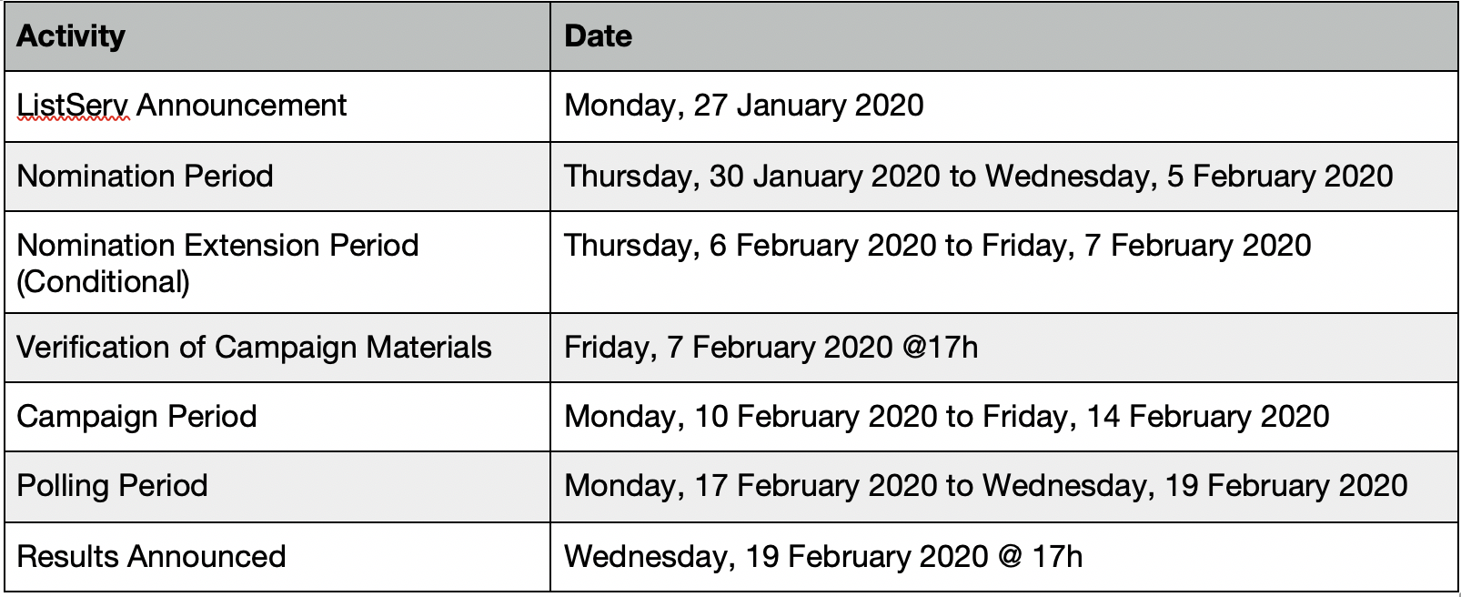
- Run!! If you have any questions, be sure to set up a meeting with one of the Execs
- Debate: February 13th, Leacock 232, 6:00-8:00pm
- Candidates Info Session: February 6th, Sherbrooke 688 Rm. 365, 6:00-8:00pm

Chief Returning Officer
- Jake Mullins is assuming CRO duties (he was previously DRO)
- Two new DROs are in the process of being hired

MOA Negotiations
- Liaising with the DPSLL office to coordinate the negotiations for the MOA

OASIS
- Coordinated with OASIS for grad ball information

Miscellaneous
- Will be hosting another President’s round table soon (date TBD)
- Finalized an Excomm meeting time

Respectfully submitted,

Jamal Tarrabain
AUS President

