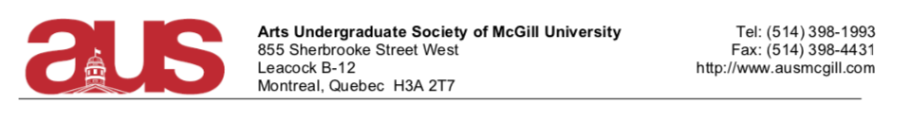
Report of Senator Darshan Daryanani
Presented to the AUS Legislative Council on January 12, 2021
Period: December 2, 2020 – January 11, 2021
Wishing Everyone Happy New Year!
Committees/Councils/Caucuses that I serve on:
- Senate
- Senate Caucus
- The Subcommittee on Teaching and Learning
- The Committee on Student Services
- The Scholarship and Student Aid Office Advisory Board
- Senate Caucus Representative on the Board Ad-Hoc Committee on Naming (BACoN)
- Senate Caucus Representative on SSMU Legislative Council
- SSMU Clubs Committee
- AUS Legislative Council
  - Faculty of Arts Council
  - Committee of Student Affairs
  - Constitution and By-law Committees

SSMU Accountability Survey:

https://forms.gle/ZA24gnqeyrJfgoKm6?fbclid=IwAR1OVLShUURLGzqkXPLmLNkAA9dvW600-rVJoVQd9MPgGGQ729_bkw-xP80

*Senate Caucus Representative

Past Activity:
- Senate
  - Additional SU Policy PASSED!
    - Thank you to the Executive for collaboration and facilitating discussions with the Arts Admin.
  - Winter Break Extension!
- Board Ad-hoc Committee on Naming (BACoN)
  - Preliminary Report

- SSMU Legislative Council
- Motion Regarding the Clarification of an International Political Position 2020-12-03 APPROVED
- Motion Regarding Amendments to the Committee Terms of Reference 2020-11-19 APPROVED
- Motion Regarding Amendments to the SSMU Positions Book 2020-12-03 APPROVED
- Motion Regarding an Amendment to the Timeline of Elections and Referenda 2020-12-03 APPROVED
- Motion Regarding the Adoption of the Gendered and Sexual Violence Policy 2020-11-19 APPROVED
- Motion Regarding the Release of Statements and Official Communications 2020-12-03 APPROVED
- Motion to adopt a SSMU 5 Year Plan 2020-11-19 APPROVED
- Medical Notes Project
  - Survey coming soon!
- Clubs Committee Meetings
  - Funding Applications Support
Respectfully Submitted,
Darshan Daryanani (he/him)
artssenator1@ssmu.ca

