Arts Undergraduate Society of McGill University
855 Sherbrooke Street West Leacock B-12
Montreal, Quebec H3A 2T7
Office: (514) 398-1993 Fax: (514) 398-4431 http://www.ausmcgill.com
March 8th 2021
Equity Plans
- Equity Calendar for next year is complete and will be distributed in next year’s departmental guides
- Open for consultation – just email me
Preview:
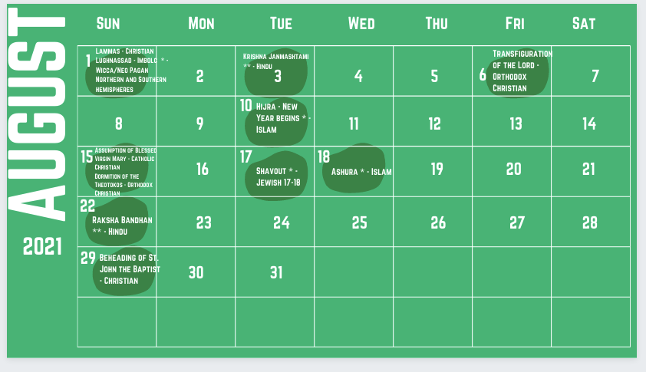

AUS Awards
- Nomination period will open early next week
The categories:
- Most Outstanding Departmental Association (large)
- Most Outstanding Departmental Association (small)
- Most Outstanding AUS-Affiliated Publication
- Most Outstanding Departmental Presiden
- Most Outstanding Departmental Executive Member
- Most Outstanding New Event/Initiative
- Most Outstanding Academic Event
- Most Outstanding Zoom Event
- Most Outstanding AUS Standing Committee
- Most Outstanding AUS Committee Member
- Most Improved Departmental Association
- Most Outstanding AUS First-Year
- Most Outstanding AUS Volunteer
- Councillor of the Year

Respectfully submitted:
Joy Hannam
AUS VP Internal

